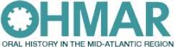
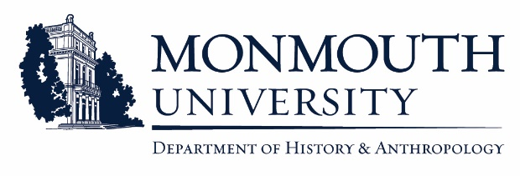
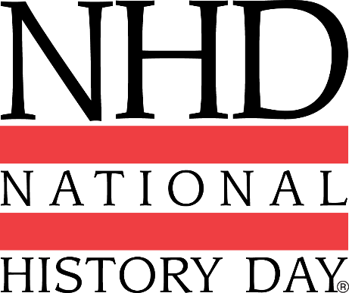

Attention Educators!
**FREE** Professional Development Opportunity at Monmouth University
Part I: “National History Day 2019: Triumph and Tragedy in History”
Part II: “Oral History in the Classroom”

Join us on Thursday, October 4th from 8am-12pm in the Guggenheim Library Computer Lab at Monmouth University for a free Teacher Training Workshop open to all grade 6-12 educators interested in integrating the National History Day program into their schools AND/OR learning more about using oral history in the classroom.

The workshop will be facilitated by Barbara Gallo, retired teacher and Member, NJ National History Day Advisory Board; and Professor Melissa Ziobro, the Monmouth University NJ National History Day Coordinator and Board Member, Oral History in the Mid-Atlantic Region.

**4 professional development credits will be offered via William Paterson University.**

Please direct inquiries, and RSVPs, to Professor Melissa Ziobro, mziobro@monmouth.edu. We ask that you respond by October 1st. (Space is limited.)

Agenda

8:00 am: Welcome by University Librarian Kurt Wagner. Light breakfast provided by the Library.
8:15- 9:45: History Day overview by Barbara Gallo
9:45-10:15: Q&A, coffee break
10:15-11:45: Oral History Workshop by Melissa Ziobro
11:45-12:00: Closing Q&A; Optional tour of the library

** National History Day: https://www.nhd.org/ ** NJ History Day: http://wpunj.edu/njhistory **
** Oral History in the Mid-Atlantic Region: https://ohmar.org/ **
** Monmouth University: http://www.monmouth.edu/university.aspx **
** Campus Map/Directions: http://www.monmouth.edu/university/maps-and-directions.aspx **

