The Paterson Silk Strike, 1913

Lesson Creator: New Jersey Center for Civic Education, Rutgers, The State University, adapted from Conflict Resolution and United States History: The Gilded Age through the Twentieth Century, 2007.

Grade level: 7-12

Lesson Overview

Following decades of labor unrest, skilled and unskilled workers-- almost all recent immigrants--organized a strike against the silk manufacturers in Paterson, New Jersey, in early 1913. The immediate cause of the strike was the imposition of four looms at one silk mill. The strike spread rapidly. The manufacturers refused to deal with the striking workers until they returned to work. Strikes were illegal in 1913. They were seen as illegal restraints of trade. The manufacturers used the power of local government to prohibit meetings and picketing.
This lesson includes a mock collective bargaining/negotiating session, as has been required by federal law under the Wagner Act since 1935. The Wagner Act legitimized the right of workers to join labor unions and to bargain collectively on “terms and conditions of employment.” In addition to learning about the Paterson Silk Strike of 1913, its context and impact, students will gain an understanding of negotiating skills and the requirements of the Wagner Act.

Time Required: Four-Five 45 minute Class Periods

Objectives: Student will be able to:
- Examine the historical context, causes, progress and consequences of the Paterson Silk Strike in 1913
- Explain the late 19th century-early 20th century view of labor strikes or boycotts as illegal
- Examine the demands of the striking silk workers and the silk manufacturers in Paterson in 1913
- Compare the context in which labor disputes were resolved before and after the 1930s
- Consider the roles of unions and government regarding American workers and the American economy today

NJ State Standards

6.1.12.A.6.a Evaluate the effectiveness of Progressive reforms in…promoting social justice
6.1.12.A.6.b Evaluate ways in which women organized to promote government policies designed to address injustice, inequality, workplace safety and immorality
6.1.12.C.6.a Evaluate the effectiveness of labor…organizations in improving economic opportunities for various groups
6.1.12.D.6.a Assess the impact of technological innovation and immigration on the development of agriculture, industry, and urban culture during the 19th century in New Jersey and the United States

Common Core Standards

SL.11-12.1 Initiate and participate effectively in a range of collaborative discussions (one-on-one, in groups, and teacher-led) with diverse partners on grades 11-12 topics, texts, and issues, building on others' ideas and expressing their own clearly and persuasively.
SL.11-12.3 Evaluate a speaker's point of view, reasoning, and use of evidence and rhetoric, assessing the stance, premises, links among ideas, word choice, points of emphasis, and tone used.
SL.11-12.4 Present information, findings, and supporting evidence, conveying a clear and distinct perspective, such that listeners can follow the line of reasoning, alternative or opposing perspectives are addressed, and the organization, development, substance, and style are appropriate to purpose, audience, and a range of formal and informal tasks.

Historical Background

Provide background for students to read or listen to and discuss to ensure understanding:

After the Civil War the pace of industrialization accelerated dramatically. The number of workers in manufacturing and construction doubled from 2 to 4 million between 1860 and 1880. The fast pace of growth and change caused conflict in relations between labor and capital. Skilled craft unions in a number of trades in 1867 formed the short-lived National Labor Union to agitate for land reform, union recognition and an 8-hour day. Followed by the Knights of Labor in 1869, an industrial rather than craft union, with unskilled as well as skilled labor in all regions of the country (coal miners, railroad workers, shoemakers, machinists, glass blowers, iron workers and others) that advocated boycotts and arbitration, worker cooperatives and a graduated income tax (there was no income tax). They had a series of successful strikes against Jay Gould’s southwestern railroad lines, but began to decline after a series of failed strikes in the late 1880s. A rival and ultimately more successful union, the American Federation of Labor (AFL) organized in 1886, with a focus on better wages, hours and working conditions rather than broad reformist goals. Strikes and boycotts by organized labor were still illegal. By this time, the focus has moved from railroad workers, miners and lumberjacks to textile workers—many of them recent immigrants; many of them women.

Paterson, New Jersey, 20 miles from New York City, had become the first industrial community in the country in 1792 with Alexander Hamilton’s investment group, the “Society of Useful Manufacturers” (see first lesson in Unit on Innovations). The Great Falls of the Passaic River powered textile mills, firearms and railroad locomotive manufacturing in Paterson. By the latter half of the 1800s, silk production had become the dominant industry in Paterson. As Paterson became the center of the nation’s silk weaving industry and the owners of the silk mills made fortunes, silk mill owners, such as Catholina Lambert, were able to build magnificent mansions.
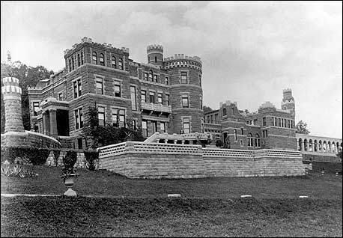
Handout or Image 1:
“Lambert’s Castle,” in Paterson, NJ, built by Catholina Lambert in 1892-1893.
Courtesy of the Passaic County Historical Society

Paterson was also the site of historic labor unrest: as early as 1828 one of the nation’s first strikes occurred here when women and children demanded a reduction to a 12-hour day. Management later hired immigrants from different ethnic groups to impede the development of worker organizations among the unskilled and semi-skilled workers. The discord between labor and industry at the turn of the 20th century was as much an ethic and class conflict as it was about economics with owners and manufacturers as well as skilled craftsmen often from England or Germany and male and unskilled workers often from Ireland, Russia, Italy or Eastern Europe and often female. New technology in the silk industry made it possible to have workers watch four rather than two looms at a time but the weavers protested this increase in workload and concern about safety and quality and went on strike. The manufacturers refused to deal with the striking workers and used the power of local government to prohibit public meetings and picketing.

The Paterson Silk Strike took place within the broader context of the Progressive Era—approx. 1900-1920--a fluid moment in American history when the lines between radical and liberal views were not clearly drawn. A broad consensus was developing about the need for government to address the problems created by rapid industrialization and mass immigration. In the 1912 election, Woodrow Wilson, Theodore Roosevelt and Eugene Debs all ran as industrial reformers (Democrat Wilson won against the conservative Republican candidate, William Taft).

The role of women was dramatically changing as the momentum built for women’s suffrage and more women joined the workforce. When textile mill owners in Lawrence, Massachusetts, lowered workers’ pay in Jan. 1912, 10,000 women and men walked out in protest. The AFL maintained that cohesive unions could not be formed among unskilled and ethnically diverse mill hands, but IWW organizers, arrived and turned the walkout into a strike involving male and female, immigrant and native-born, skilled and unskilled, workers. The workers maintained their solidarity for weeks through rallies, parading, and picketing. Mill owners tried to break the strike through the AFL’s United Textile Workers Union, which included only the skilled workers, but that failed. The mill owners approved one of the workers’ demands, a 5 percent pay raise. But the workers continued to strike until mid-March when the owners accepted all of the workers’ original demands. The success of the Lawrence Strike was widely hailed as a triumph of labor organization and solidarity among multi-ethnic, factory operatives. Working class immigrant women had played a leading role in the successful strike in Lawrence, MA. These dramatic victories encouraged the hopes of many reformers, revolutionaries and feminists. It made the idea of workers’ influence on the system of production seem possible.

By 1910, Henry Doherty had built the largest silk mill in the Paterson area, positioning the looms so that each weaver could watch four of them. In 1910 and 1912, Doherty’s weavers had refused to work four looms and had walked out. In 1913, in addition to demanding a return to two looms (which only affected the broad-silk workers), the workers at the Doherty silk mill gained the backing of the other silk weavers, dyer’s helpers and ribbon weavers with a unifying demand for an eight-hour day that affected all workers. Paterson silk workers had been working ten-hour days, or 55-hour weeks (this included a half day on Saturday). An eight-hour day had been the goal of organized labor since the 1880s. Local silk workers called, planned and organized the strike with the aid of Local 152 of the International Workers of the World (IWW). They brought in experienced IWW speakers to make rallying speeches at their daily mass meetings. By February 24, 1913 there was a general strike by Paterson silk workers and the silk mills in Paterson were closed down.

Share and Discuss Handout or Image 2 with the class: “6,000 Weavers Quit; I.W.W. Leaders Held; Paterson Police break up Mass meeting and Arrest Elizabeth Flynn and Carlo Tresca,” New York Times, Feb. 26, 1913.

Conduct a Collective Bargaining Session
Before we look at what actually happened to end this strike, we’re going to do a mock collective bargaining session as has been required by federal law since the Wagner Act in 1935. The Wagner or National Labor relations Act legitimized the right of workers to join labor unions and to bargain collectively on “terms and conditions of employment.” This is ahistorical so that you can compare what actually happened in 1913 with the approach after 1935 and better understand the difference it has made in labor relations. Explain to the class that they are going to bargain about “wages, hours and other terms and conditions of employment.” This is the law today and has been since the 1930s but it wasn’t in 1913. Strikes were illegal then. You will each play an actual historical figure who was involved in the 1913 Paterson Silk Strike.

Directions: Divide the class into two groups: (Manufacturers and Workers/Union reps.) and assign the following 15 roles. Depending on the size of your class, you may want to establish two separate groups of ten. If there aren’t enough students for all of these roles, simplify the number to represent the core groups (e.g. remove a manufacturer, a union rep and one or more silk workers). Provide students with handouts 1, 2, 3, 4, 6, 7, 8 and 9. Students should become familiar with their own role and the position and interests of that individual as well as the positions and interests of the other historical figures involved in the strike in Paterson in 1913.

Review the historic figures who will be involved in the negotiations to make sure that the students understand what role they will be playing.
The Silk Manufacturers:
- Henry Doherty
- Catholina Lambert
- Samuel McCollom
- Moses Strauss

Workers/Union reps.:
- John Golden
- Ewald Koettgen
- Adolf Lessig
- Louis Magnet
- Carrie Golzio
- Hannah Silverman
- Scully Bell
- Bill Haywood
- Elizabeth Gurley Flynn
- Carlo Tresca

An observer/recorder who does not participate but takes notes about the process and the results. You could have your observers be representatives from different newspapers and report from different perspectives, for examples, the NY Times, the Paterson Newspaper, a socialist paper, or simply observe and take notes. Observing is a skill that we do not practice enough. Being a good observer is very helpful in every aspect of what we do in life. By carefully observing others, we can also learn. And since you have several groups working simultaneously in the classroom, the observer also helps you the teacher to better appreciate what is going on in each group.

The Silk Manufacturers (Handout or Image 3)

Catholina Lambert began work as a ten-year old boy in a cotton mill in Yorkshire, England. At 17, he had immigrated to the United States and became an office boy in a Boston silk firm. Four years later he purchased a partnership in the firm, renamed it Dexter, Lambert & Co. and moved it to Paterson. There he made enough money from his five silk mills to build an English-style castle and to buy some 400 original paintings by European masters. He was part of the old-line manufacturing group that dominated the Silk Association and the Paterson Board of Trade. Lambert was 79 years old in 1913 and took a very hard line in the strike. He never recovered from the strike. After World War I he was forced to declare bankruptcy and to sell his famous art collection.
Samuel McCollom was another large silk manufacturer in Paterson. He believed that he had the right to hire whomever he pleased. Fed up with workers’ interference, he moved several of his larger factories to rural Pennsylvania. McCollom took a hard line against the unions and strikers in Paterson. He opposed any union. He had been responsible for the restructuring of the local city government which weakened the labor-supported Board of Alderman and created the more powerful, non-elected (and business influenced) Board of Commissioners. McCollom urged silk manufacturers to stand as a united front against the strikers.
Henry Dougherty, Jr. was a proud, independent, aging mill owner who had worked his way up. Arriving in Paterson as a young weaver from England in 1868, he soon became a shop foreman. In 1879, he started his own silk shop with a partner and one loom. Within two years, his business had expanded to 100 looms and 250 workers. In 1910, he built the largest mill in Paterson, with state-of-the-art looms. He increased the loom assignments from two to four. He sought and received prior approval from the AFL’s United Textile Workers, the recognized union of most of the weavers at the time. He was shocked to see the majority of his workers walk out of his fine new mill after they turned to the IWW Local 152 for support. As the strike spread and the months rolled by, Dougherty’s business suffered tremendously. He tried to find some point of accommodation.
Moses Strauss was a successful Jewish manager of two Paterson silk mills, one of which employed male weavers on older, slower, labor-intensive German looms and the other with female weavers on new, high-speed looms. He believed that the skilled male weavers would be replaced in 15-20 years because of technological advances. He had little sympathy for the complaints of the higher-paid male workers. He was paternalistic towards the female workers. Strauss was surprised when in earl y March 1913 some 200 women and girls walked out of one of the miles because they had never told him that they had any grievances.
The Unions (Handout or Image 4)
The American Federation of Labor (AFL) and John Golden. The AFL was a conservative, craft-oriented union. By 1913 it had been in existence for 30 years. At this point it had little interest in recruiting unskilled, female or immigrant workers. The AFL sought shorter working hours and better pay. The AFL and IWW had very different approaches to labor-management relations and were fiercely vying with each other for membership in the early 1900s, especially after the IWW victory for textile workers in Lawrence, MA in 1912. John Golden was president of the AFL’s United Textile Workers Union. He was appalled at the success of the IWW hotheads in the Lawrence, MA strike. To Golden, IWW leaders were anarchists and lawbreakers who urged the uneducated masses of newly arrived immigrants to sabotage businesses and all workers would lose. In April 1913, Golden opened two recruiting offices in Paterson in an effort to offer workers a less radical approach. He had little success because many weavers saw the AFL as a collaborator with Doherty’s plan to implement the four-loom speedup. Golden believed that four looms were inevitable and should be accepted.
The Industrial Workers of the World (IWW) and Bill Haywood. The Industrial Workers of the World (IWW) Founded in 1905 in Chicago and originally spearheaded by western miners and lumberjacks, the IWW became famous in the east after its 1912 victory in the Lawrence, Ma, wool textile strike. Like the Knights of Labor before it and the CIA after it in the 1930s, the IWW reached pit to the workers who the AFL would not or could not organize—the unskilled new immigrants from southern and eastern Europeans, women, blacks and Hispanics. The IWW wanted to replace employer management with worker self-management and to abolish the wage system. The IWW believed that class struggle was inevitable. They were skeptical of politics and believed in the power of the strike. The IWW encouraged workers to take increasing democratic responsibilities for running their local shop and their industry until worker management extended everywhere. They saw no legitimacy in management or in conservative unions, such as the AFL which recruited only skilled workers and was narrowly focused on wages and hours. The IWW neither started nor directed the Paterson strike. Its leaders were invited as speakers and advisors. At the height of the strike, almost 10,000 Paterson silk workers joined the IWW.
William “Big Bill” Haywood was president of the IWW. He had participated in the violent labor-management battles in the western mining camps. Haywood was an imposing figure, well over six feet tall. He arrived in Paterson on March 7, 1913 after the strike had already been planned and started. His chief role was to make public speeches stressing worker equality and the need for solidarity to achieve their goals. Haywood was a bridge to New York socialists and philanthropists and helped to plan the “Paterson Pageant” on June 7, 1913.
Ewald Koettgen was the only full-time organizers of the IWW local 152. Of German descent, Koettgen had worked in Paterson as a ribbon weaver since the 1890s. He had been a member of the IWW for several years and was deeply committed to the organization’s radical goals and militant methods. At age 40, he was tall and gaunt, with deep lines in his face. As leader of the IWW silk workers local 152, Koettgen had built his membership to nearly 500. In January 1913, he was elected chairman of the IWW’s National textile Union. Koettgen was out of town when the Doherty mill workers decided to strike in February 1913 but hurried back to help local 152 sound out its membership about a general strike.
The Silk Workers (Handout or Image 5)
There were several different groups of silk workers. The ribbon weavers highly skilled men and women who wove narrow silks for hat bands and ties. Most of them came from English and German background and were native-born. The broad silk weavers were semi-skilled men and women who worked the machines that wove silk cloth for dresses. Most of them were Catholics from Italy or Jews from Eastern Europe who had immigrated to Paterson within the last 10-15 years. The dyer’s helpers were unskilled men who dyed the silk yarn before it was women. Most of them were from Italy. Although the protest against four-looms only affected the ribbon weavers, the worker’s demand for an eight-hour was a unifying cry for all of the silk workers.
Adolf Lessig was a broad silk weaver of German descent who had been weaving both cotton and silk since the 1880s. He moved to Paterson in 1902 and briefly joined the AFL but switched to the IWW shortly after it was founded in 1905. When Doherty mill workers decided to walk out to protest working four looms, Lessig inquired among local 152 members in other mills about supporting a general strike. Lessing called a series of mass meetings and formed the executive Strike Committee.
Louis Magnet was an experience ribbon weaver. He was concerned that many women were moving into the craft and willing to work for less at longer hours. He was an active member in the Socialist Party but did not agree with the industrial radicalism of the IWW. He tried but failed to develop alternatives to the IWW during the strike.
Carrie Golzio was a second-generation broad silk and jaquard weaver. Her parents had been involvement in labor disputes back in their native Piedmont region in Northern Italy, as well as in Paterson. Golzio was in her 20s in 1913 and was drawn into the IWW by the dynamic speaking of Elizabeth Gurley Flynn. As a skilled craftsperson, Golzio took pride in the quality of her workmanship. She feared that the four-loom system would reduce the quality of her work. She believed that the mill owners took the workers for granted and was drawn together in a cooperative spirit with eastern European Jewish female silk weavers who worked with her.
Hannah Silverman was a 17-year old skilled Jewish employee who enthusiastically took part in the picketing at the mill. The weekly women-only meetings helped to inspire young girls like Hannah Silverman to emerge as leaders in the strike. Silverman was captain of the pickets and one of the co-directors of the Paterson Strike Pageant at Madison Square Garden.
Scully Bell was an unskilled dye worker from Southern Italy. It was horrible work that often required double shifts just to stay employed. Dyer’s helpers added chemicals to the large vats of boiling water to which the silk yarns were added. The dye house was dirty and always filled with steam and fumes. The dyer’s helpers wore wooden clogs to try to protect their feet from the slop on the floor. The dyer’s helpers were the most easily replaced because the job could be learned in a week.
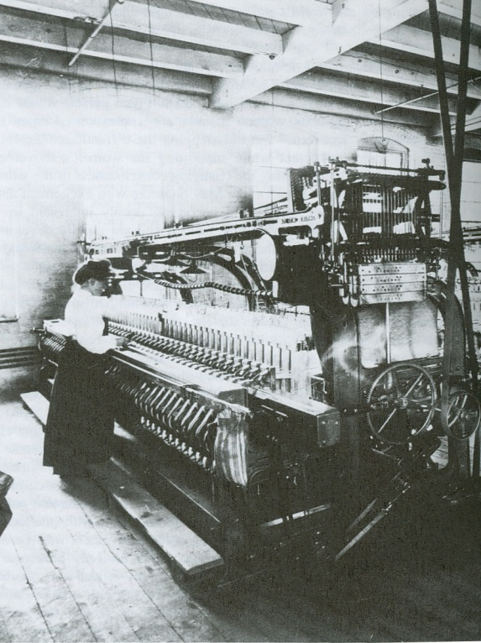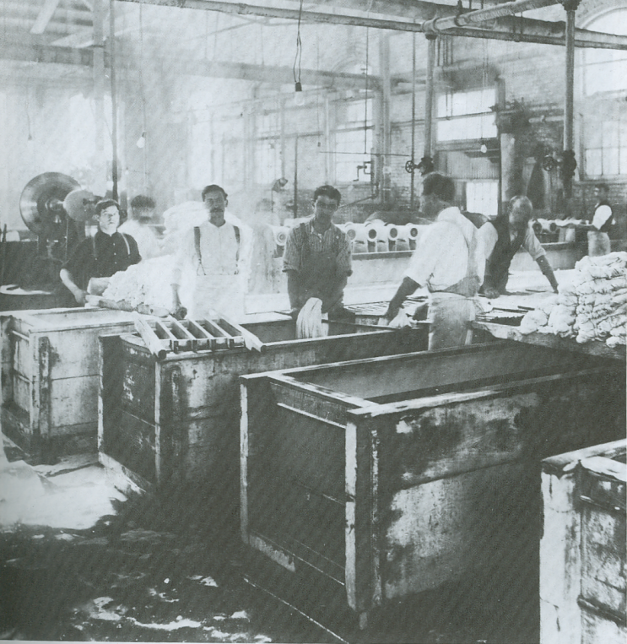
Silk ribbon weaver at a Paterson Silk Mill, 1906 Dyers in a Paterson silk mill, 1908,
Passaic County Historical Society Passaic County Historical Society

Review and discuss Steps in Conflict Resolution (Handout or Image 6)
1. Recognize emotions and avoid having them interfere—avoid “triggers”: verbal or nonverbal behaviors that result in anger or other negative emotional reactions and interfere with the communication between two (or more) people (such as finger pointing, eye rolling, name calling, etc.).
2. Use active listening skills: Ask questions, paraphrase, repeat to let the other person know what you think was said
3. Identify the underlying interests: We often take positions that make it difficult to negotiate. However, if we identify the underlying interests, there is often an area of overlapping interests. For example,
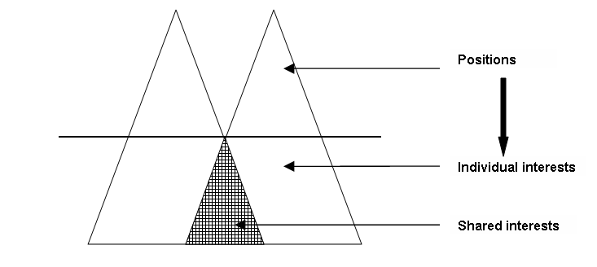
4. Seek (Brainstorm) possible solutions
5. Use objective criteria to evaluate possible solutions
6. Identify solutions that all parties can accept (meet common interests)
7. Agree on the best solution and to come back to the problem if the solution does not work
8. Look long-term to preserve the relationship.
Review the positions and interests of the Silk Manufacturers, the Union Leaders and the Silk Workers (Handout or Image 7)
The Silk Manufacturers
Position:
- Will not deal with the IWW because it is a lawless organizations
- Will listen to grievances from individual employees
- Will make adjustments only when the strikers return to work.
Interests:
- Maintain a handsome profit on investment—by 1913 Paterson silk manufacturers were caught in declining profits resulting from lower prices due to an increasingly competitive industry
- Reduce labor costs and/or increase labor productivity to remain competitive
- Main managerial control over the terms and conditions of employment
- Wanted satisfied, reliable, loyal, skilled workers: high turnover and work stoppages, walkouts and strikes were costly.

The Silk Workers
Position:
- Tending four looms made one worker do the work of two. It was a physical hardship.
- The for-loom system would result in lower quality.
- Workers wanted more control over the conditions of their employment
- Workers wanted a fair system where greater profits due to increased productivity was shared with the workers.
- Technological improvement were acceptable as long as it was not used solely to reduce their wages.
Interests:
- Management should share the economic benefits of new technology and productivity with workers.
- Unskilled workers simply wanted to improve their hours, wages and working conditions.
- Skilled workers feared the downgrading of skills by the use of machines.
- The only unifying demand was for an eight-hour day.

The I.W.W.
Position:
- The industrial, capitalistic wage system exploited workers and was undemocratic.
- The solution and goal is to replace capitalism with worker management.
- Strikes are battles in the class struggle that will continue until the ultimate victory of workers.
Interests:
- Maintain and enhance the reputation of a labor organization that was tough in dealing with management and cold win concessions to improve workers’ income and working conditions.
- Continue the momentum of victory from Lawrence, MA.
- Need to have manufacturers negotiate with them.
Handout and review the Wagner Act (Handout or Image 8). The Wagner Act of 1935 legitimized the right of workers to join labor unions and to bargain collectively on “terms and conditions of employment.”
Sec. 7: Guarantees employees the right to self-organization, to form, join or assist labor organizations, to bargain collectively through representatives of their own choosing, and to engage in other concerted activities for the purpose of collective bargaining…
Sec. 8 defines as unfair labor practices, for an employer:
1. to interfere with, restrain or coerce employees in the exercise of rights guaranteed in section 7;
2. to interfere with the formation or administration of any labor organization…
3. to discriminate in the hiring or tenure of employment or any term or condition of employment; to encourage or discourage membership in a labor organization
4. to discharge or otherwise discriminate against an employee because he has filed charges or given testimony under this Act;
5. to refuse to bargain collectively with the representatives of his employees.
Employers and employees are required to bargain over “wages, hours, and other terms and conditions of employment.” This has been defined over the years to include wages and fringe benefits, grievance procedures, arbitration, health and safety, nondiscrimination clauses, no-strike clauses, length of contract, management rights, discipline, seniority and union security

Directions for Mock Collective Bargaining (Handout or image 9)

Set up the groups of 15 around a table.
Step 1: Internal Negotiations
- The manufacturers should meet, discuss their positions and interests, try to identify options that might be acceptable to workers and manufacturers and agree on the best strategy to take to the collective bargaining session with the workers and union reps. and who will represent the manufacturers in the collective bargaining session.
- The silk workers and IWW and AFL union reps should meet, discuss their positions and interests, try to identify options that might be acceptable to workers and manufacturers, and agree on the best strategy to take to the collective bargaining session with the manufacturers and who will represent the workers in the collective bargaining session with the manufacturers
Step 2: Collective Bargaining
- The designated representatives from the workers/unions and the manufacturers will meet for a collective bargaining session
- The representatives will lay out and negotiate their views on hours, wages and conditions of employment and try to come to an agreement on these issues.
- If these negotiations lead to an offer that differs from their internal agreement, either side may ask for a recess to consider the proposal with the internal group
- The observer/recorder/reporters should watch their assigned groups and take notes on the process and the results. The observers do not participate directly in the negotiations.
The Debriefing: What happened and what were the results from each negotiating group? (Handout or Image 10)
Debriefing is critical to get your students out of their roles, especially if a student finds his or her role incompatible with his or her personal views. We are not trying to make up history but rather to engage and interest students in what really happened. Ask for comments from the observers in each group (and add your own observations) about:

The Process
- Did the participants use active listening skills?
- Where there missed opportunities for compromise?
- Did rhetoric get in the way of pursuing the interests?
- Were the role played with historical accuracy?

The Results
- Review the results from each collective bargaining group
- Review what really happened in history
- Compare the results of the mock collective bargaining and what really happened in history
- Consider the reasons for any similarities or differences
The rubrics in the Negotiation Evaluation Form (Handout or Image 11) might be used to evaluate each student’s involvement in the process of negotiating.

What really happened in Paterson in 1913?

Provide oral or written information, including Handout or Image 12, about what really happened in the Paterson Silk Strike in 1913 or have students research and explain.

The Paterson silk workers had forged an unprecedented united front. However, the manufacturers were equally united and for the first time, the silk manufacturers formed a united Silk Manufacturers Association. They refused to negotiate with the strikers and rejected all attempts at third-party mediation. The owners tried to separate the strikers from the IWW, to split the native-born and immigrants, to pit different ethnic groups against each other. They even invited the United Textile Workers to intervene. But these efforts just made the strikers even more determined. The owners used the power of local government, including the Paterson police, against the strikers: more than 2,200 strikers were arrested mostly for “disorderly conduct” in peaceful picketing. They filled the jails but did little to hurt the strike. The city closed the two halls in which the strikers had been meeting in Paterson, forcing the strikers to meet outside of the city, in nearby Haledon, which had a socialist mayor.
The strikers met at the Botto House (now the American Labor Museum ).

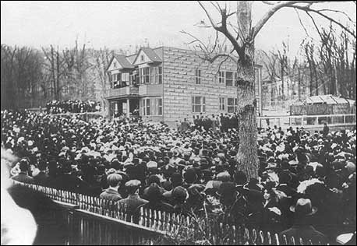
Strikers meet at the Botto House in Haledon, just outside of Paterson, 1913
Passaic County Historical Society

The strikers sought to widen their support and fundraising. They staged an innovative “Pageant of the Paterson Silk Strike” in Madison Square Garden in June 1913, to obtain sympathy and support. They had articles and political cartoons supporting their efforts in labor magazines.

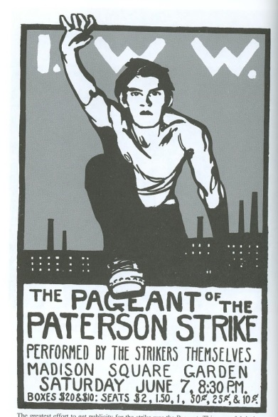
Advertisement for the Pageant of the Paterson Silk Strike, from The Masses, June 1913

While the Pageant contributed to the united spirit among the workers, it split the leaders: Haywood supported it but Flynn thought that it diverted the workers attention from the real issue-the strike. The strike turned into an endurance contest. The silk manufacturers had greater resources. They had silk mills in PA and other locations and the strikers were unable to close down mills outside of Paterson. The manufacturers were also supported by other industrialists and most of the newspapers were seeking to halt the growth of the radical IWW. By June 1913, the strikers had used up all personal saving and contributions and were down to one meal a day. The manufacturers ultimately starved the workers back to work after four long months (late February-mid-June, 1913).

Analyze the political cartoon below (Handout or Image 13):

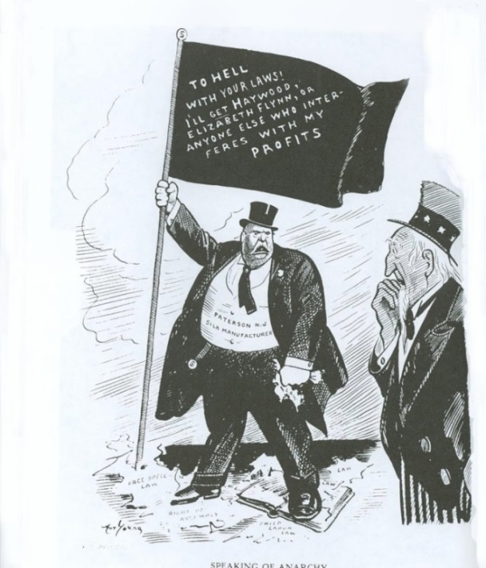
“To Hell with Your Laws,” Political cartoon from Solidarity, June 7, 1913.
Source analysis:
- What is the source? Solidarity
- What kind of publication if “Solidarity”?
- What would be its viewpoint? Pro-strikers
- When was it published? June 1913
- Why was it published? To gain support for the striking silk workers in Paterson

Content analysis:
- What is on the flag? To Hell with Your Laws! I’ll get Harwood, Elizabeth Flynn or anyone else who interferes with my profits.
- Who is the man with the flag? Paterson Silk Manufacturer
- What is the man standing on? Paterson silk manufacturer standing on ripped pages of “free speech,” “right of assembly,” and “child labor” laws.
- Who is the man watching? Uncle Sam = the country
- What is the cartoon trying to say? The Paterson Silk Manufacturers are greedy and don’t care about anything other than making money.

Do you think this is an effective political cartoon? Why or why not?

Compare what really happened with the results of the in-class negotiations and discuss why.
Go to https://www.youtube.com/watch?v=UGNv6kPt950.

Discuss the Historical Impact of the Paterson Silk Strike

The political parties responded to some extent to the grievances of organized labor with the Clayton Act in 1914. President Wilson was the first president to address an annual convention of organized labor (the AFL) in 1916. During World War I, President Wilson supported union organization and collective bargaining in industries with government contracts and union membership—almost all of it AFL which supported the war effort—grew dramatically. Debs, as well as the bulk of the Socialist Party, opposed the war. With vigilante actions and government prosecutions, the IWW and the Socialist Party were effectively crushed between 1917 and 1920, along with them the hopes of replacing capitalism with worker management. Instead, a new legal context for labor and management relations was developed, with the support of the Roosevelt administration, which required peaceful collective bargaining but only on issues related to hours, wages and other terms and conditions of employment.

Assessment: Have students respond to the following questions or have a classroom discussion (Handout or Image 14)

- Did the Paterson silk workers and silk mill owners have any common interests? If so, what were they? Could these have been used to achieve a resolution of the workers’ grievances to everyone’s satisfaction?

- Were there ways in which the asymmetrical power relationships between workers and employers in the late 19th and early 20th centuries could have been equalized? How did the Wagner Act of 1935 help to equalize the power of employees and employers?

- Was the 1913 Paterson Silk Strike a failure for the workers? For the manufacturers? For the IWW? For the AFT? Why or why not?

- Discuss the critical role of women in the Paterson Silk Strike? Why were women so involved in the Paterson Silk Strike? Did working class women change their self-perception after taking leadership role sin the strike?
- What roles do unions and government play in regard to American workers today? Labor unions in most European countries are political parties. Here they are lobbyists. Is our system of labor relations working? What might be a better system?

Extension
Visit the American Labor Museum. The Botto House in Haledon, NJ, where the Paterson silk workers met during the 1913 strike has been turned into a museum about the labor movement with a special emphasis on immigrants. It has exhibits, educational programs and other events. For more information go to http://www.labormuseum.net/ or call 973-595-7953.
Visit the Paterson Museum in the former Rogers Locomotive and Machine works building at 2 Market Street in Paterson. The museum aims to preserve and display the industrial history of Paterson. Founded in 1925, it is owned and run by the city of Paterson and its mission is to preserve and display the industrial history of Paterson. The museum is open daily 10 a.m. to 4 p.m. For additional information go to http://www.patersonnj.gov/department/?structureid=16 or call 973-321-1260.
Visit Lambert’s Castle, originally called Belle Vista, is located within the Garret Mountain Reservation at 3 Valley Road in Paterson. Because of its medieval architecture, size and view, it is often used for weddings, concerts, teas and other events. It is open for visits. For more information go to http://www.lambertcastle.org/ or call 973-248-0085.

Handout 1

“Lambert’s Castle,” in Paterson, NJ
built by Catholina Lambert in 1892-1893.
Courtesy of the Passaic County Historical Society

Handout 2

6,000 Weavers Quit; I.W.W. Leaders Held; Paterson Police break up Mass meeting and Arrest Elizabeth Flynn and Carlo Tresca

Paterson, NJ, Feb. 23.

Under the leadership of William Haywood’s direct action branch of the “Industrial Workers of the World” the silk weavers and dyers here went out on strike today as a protest against new and improved machinery…
When the first 4,000 of the strikers left their looms this morning, they attempted to parade to the other mills in the hope of rallying supporters to their cause the Paterson police force, under command of Police Chief Bimson, bore down on the strikers, seized their leaders and sent the chief of them out of town on an Erie Railroad train.
Disconcerted in their attempt to parade, the strikers attempted to have a mass meeting in a hall they had hired for the occasion. Police Chief Bimson charged upon the meeting place and seized the three principal speakers, among them Elizabeth Gurley Flynn and Carlo Tresca, both I.W.W. leaders associated in the waiters’ strike in New York recently.
The strikers allowed their parade leader to be drummed out of town and allowed the speakers at their mass meeting to be placed under arrest without bringing on a general riot. But for many hours after the arrests the strikers moved in disorganized masses about town, threatening the police and the Mayor and denouncing the treatment accorded them…

Source: The New York Times, February 26, 1913

Handout 3: The Silk Manufacturers

Catholina Lambert began work as a ten-year old boy in a cotton mill in Yorkshire, England. At 17, he had immigrated to the United States and became an office boy in a Boston silk firm. Four years later he purchased a partnership in the firm, renamed it Dexter, Lambert & Co. and moved it to Paterson. There he made enough money from his five silk mills to build an English-style castle and to buy some 400 original paintings by European masters. He was part of the old-line manufacturing group that dominated the Silk Association and the Paterson Board of Trade. Lambert was 79 years old in 1913 and took a very hard line in the strike. He never recovered from the strike. After World War I he was forced to declare bankruptcy and to sell his famous art collection.
Samuel McCollom was another large silk manufacturer in Paterson. He believed that he had the right to hire whomever he pleased. Fed up with workers’ interference, he moved several of his larger factories to rural Pennsylvania. McCollom took a hard line against the unions and strikers in Paterson. He opposed any union. He had been responsible for the restructuring of the local city government which weakened the labor-supported Board of Alderman and created the more powerful, non-elected (and business influenced) Board of Commissioners. McCollom urged silk manufacturers to stand as a united front against the strikers.
Henry Dougherty, Jr. was a proud, independent, aging mill owner who had worked his way up. Arriving in Paterson as a young weaver from England in 1868, he soon became a shop foreman. In 1879, he started his own silk shop with a partner and one loom. Within two years, his business had expanded to 100 looms and 250 workers. In 1910, he built the largest mill in Paterson, with state-of-the-art looms. He increased the loom assignments from two to four. He sought and received prior approval from the AFL’s United Textile Workers, the recognized union of most of the weavers at the time. He was shocked to see the majority of his workers walk out of his fine new mill after they turned to the IWW Local 152 for support. As the strike spread and the months rolled by, Dougherty’s business suffered tremendously. He tried to find some point of accommodation.
Moses Strauss was a successful Jewish manager of two Paterson silk mills, one of which employed male weavers on older, slower, labor-intensive German looms and the other with female weavers on new, high-speed looms. He believed that the skilled male weavers would be replaced in 15-20 years because of technological advances. He had little sympathy for the complaints of the higher-paid male workers. He was paternalistic towards the female workers. Strauss was surprised when in earl y March 1913 some 200 women and girls walked out of one of the miles because they had never told him that they had any grievances.

Handout 4: The Unions
The American Federation of Labor (AFL) and John Golden. The AFL was a conservative, craft-oriented union. By 1913 it had been in existence for 30 years. At this point it had little interest in recruiting unskilled, female or immigrant workers. The AFL sought shorter working hours and better pay. The AFL and IWW had very different approaches to labor-management relations and were fiercely vying with each other for membership in the early 1900s, especially after the IWW victory for textile workers in Lawrence, MA in 1912. John Golden was president of the AFL’s United Textile Workers Union. He was appalled at the success of the IWW hotheads in the Lawrence, MA strike. To Golden, IWW leaders were anarchists and lawbreakers who urged the uneducated masses of newly arrived immigrants to sabotage businesses and all workers would lose. In April 1913, Golden opened two recruiting offices in Paterson in an effort to offer workers a less radical approach. He had little success because many weavers saw the AFL as a collaborator with Doherty’s plan to implement the four-loom speedup. Golden believed that four looms were inevitable and should be accepted.
The Industrial Workers of the World (IWW) and Bill Haywood. The Industrial Workers of the World (IWW) Founded in 1905 in Chicago and originally spearheaded by western miners and lumberjacks, the IWW became famous in the east after its 1912 victory in the Lawrence, Ma, wool textile strike. Like the Knights of Labor before it and the CIA after it in the 1930s, the IWW reached pit to the workers who the AFL would not or could not organize—the unskilled new immigrants from southern and eastern Europeans, women, blacks and Hispanics. The IWW wanted to replace employer management with worker self-management and to abolish the wage system. The IWW believed that class struggle was inevitable. They were skeptical of politics and believed in the power of the strike. The IWW encouraged workers to take increasing democratic responsibilities for running their local shop and their industry until worker management extended everywhere. They saw no legitimacy in management or in conservative unions, such as the AFL which recruited only skilled workers and was narrowly focused on wages and hours. The IWW neither started nor directed the Paterson strike. Its leaders were invited as speakers and advisors. At the height of the strike, almost 10,000 Paterson silk workers joined the IWW.
William “Big Bill” Haywood was president of the IWW. He had participated in the violent labor-management battles in the western mining camps. Haywood was an imposing figure, well over six feet tall. He arrived in Paterson on March 7, 1913 after the strike had already been planned and started. His chief role was to make public speeches stressing worker equality and the need for solidarity to achieve their goals. Haywood was a bridge to New York socialists and philanthropists and helped to plan the “Paterson Pageant” on June 7, 1913.
Ewald Koettgen was the only full-time organizers of the IWW local 152. Of German descent, Koettgen had worked in Paterson as a ribbon weaver since the 1890s. He had been a member of the IWW for several years and was deeply committed to the organization’s radical goals and militant methods. At age 40, he was tall and gaunt, with deep lines in his face. As leader of the IWW silk workers local 152, Koettgen had built his membership to nearly 500. In January 1913, he was elected chairman of the IWW’s National textile Union. Koettgen was out of town when the Doherty mill workers decided to strike in February 1913 but hurried back to help local 152 sound out its membership about a general strike.
Handout 5: The silk workers
There were several different groups of silk workers. The ribbon weavers highly skilled men and women who wove narrow silks for hat bands and ties. Most of them came from English and German background and were native-born. The broad silk weavers were semi-skilled men and women who worked the machines that wove silk cloth for dresses. Most of them were Catholics from Italy or Jews from Eastern Europe who had immigrated to Paterson within the last 10-15 years. The dyer’s helpers were unskilled men who dyed the silk yarn before it was women. Most of them were from Italy. Although the protest against four-looms only affected the ribbon weavers, the worker’s demand for an eight-hour was a unifying cry for all of the silk workers.
Silk ribbon weaver at a Paterson Silk Mill, 1906 Dyers in a Paterson silk mill, 1908,
Passaic County Historical Society Passaic County Historical Society

Adolf Lessig was a broad silk weaver of German descent who had been weaving both cotton and silk since the 1880s. He moved to Paterson in 1902 and briefly joined the AFL but switched to the IWW shortly after it was founded in 1905. When Doherty mill workers decided to walk out to protest working four looms, Lessig inquired among local 152 members in other mills about supporting a general strike. Lessing called a series of mass meetings and formed the executive Strike Committee.

Louis Magnet was an experience ribbon weaver. He was concerned that many women were moving into the craft and willing to work for less at longer hours. He was an active member in the Socialist Party but did not agree with the industrial radicalism of the IWW. He tried but failed to develop alternatives to the IWW during the strike.

Carrie Golzio was a second-generation broad silk and jaquard weaver. Her parents had been involvement in labor disputes back in their native Piedmont region in Northern Italy, as well as in Paterson. Golzio was in her 20s in 1913 and was drawn into the IWW by the dynamic speaking of Elizabeth Gurley Flynn. As a skilled craftsperson, Golzio took pride in the quality of her workmanship. She feared that the four-loom system would reduce the quality of her work. She believed that the mill owners took the workers for granted and was drawn together in a cooperative spirit with eastern European Jewish female silk weavers who worked with her.

Hannah Silverman was a 17-year old skilled Jewish employee who enthusiastically took part in the picketing at the mill. The weekly women-only meetings helped to inspire young girls like Hannah Silverman to emerge as leaders in the strike. Silverman was captain of the pickets and one of the co-directors of the Paterson Strike Pageant at Madison Square Garden.

Scully Bell was an unskilled dye worker from Southern Italy. It was horrible work that often required double shifts just to stay employed. Dyer’s helpers added chemicals to the large vats of boiling water to which the silk yarns were added. The dye house was dirty and always filled with steam and fumes. The dyer’s helpers wore wooden clogs to try to protect their feet from the slop on the floor. The dyer’s helpers were the most easily replaced because the job could be learned in a week.

Handout 6: Steps in Negotiations

- Recognize emotions and avoid having them interfere—avoid “triggers”: verbal or nonverbal behaviors that result in anger or other negative emotional reactions and interfere with the communication between two (or more) people (such as finger pointing, eye rolling, name calling, etc.).

- Use active listening skills: Ask questions, paraphrase, repeat to let the other person know what you think was said

- Identify the underlying interests

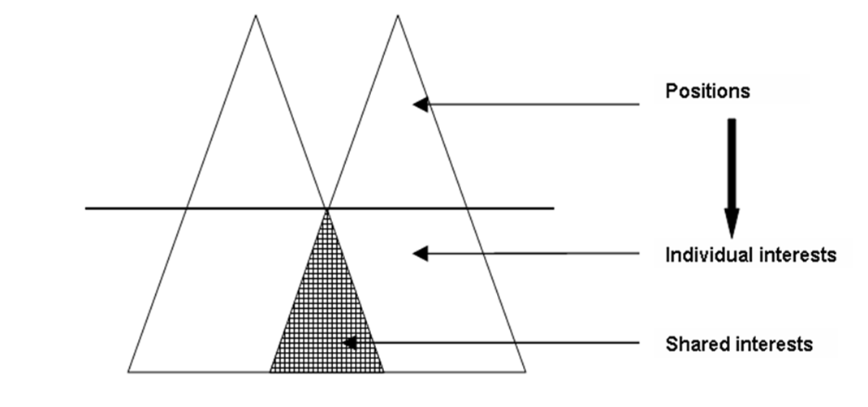

- Seek (Brainstorm) possible solutions

- Use objective criteria to evaluate possible solutions

- Identify solutions that all parties can accept (meet common interests)

- Agree on the best solution and to come back to the problem if the solution does not work

8. Look long-term to preserve the relationship.
Handout 7: Positions and Interests
The Silk Manufacturers
Position:
- Will not deal with the IWW because it is a lawless organizations
- Will listen to grievances from individual employees
- Will make adjustments only when the strikers return to work.
Interests:
- Maintain a handsome profit on investment—by 1913 Paterson silk manufacturers were caught in declining profits resulting from lower prices due to an increasingly competitive industry
- Reduce labor costs and/or increase labor productivity to remain competitive
- Main managerial control over the terms and conditions of employment
- Wanted satisfied, reliable, loyal, skilled workers: high turnover and work stoppages, walkouts and strikes were costly.

The Silk Workers
Position:
- Tending four looms made one worker do the work of two. It was a physical hardship.
- The for-loom system would result in lower quality.
- Workers wanted more control over the conditions of their employment
- Workers wanted a fair system where greater profits due to increased productivity was shared with the workers.
- Technological improvement were acceptable as long as it was not used solely to reduce their wages.
Interests:
- Management should share the economic benefits of new technology and productivity with workers.
- Unskilled workers simply wanted to improve their hours, wages and working conditions.
- Skilled workers feared the downgrading of skills by the use of machines.
- The only unifying demand was for an eight-hour day.

The I.W.W.
Position:
- The industrial, capitalistic wage system exploited workers and was undemocratic.
- The solution and goal is to replace capitalism with worker management.
- Strikes are battles in the class struggle that will continue until the ultimate victory of workers.
Interests:
- Maintain and enhance the reputation of a labor organization that was tough in dealing with management and cold win concessions to improve workers’ income and working conditions.
- Continue the momentum of victory from Lawrence, MA.
- Need to have manufacturers negotiate with them.
Handout 8: Collective Bargaining under the National Labor Relations Act

Sec. 7: Guarantees employees the right to self-organization, to form, join or assist labor organizations, to bargain collectively through representatives of their own choosing, and to engage in other concerted activities for the purpose of collective bargaining…

Sec. 8 defines as unfair labor practices, for an employer:
1. to interfere with, restrain or coerce employees in the exercise of rights guaranteed in section 7;
2. to interfere with the formation or administration of any labor organization…
3. to discriminate in the hiring or tenure of employment or any term or condition of employment; to encourage or discourage membership in a labor organization
4. to discharge or otherwise discriminate against an employee because he has filed charges or given testimony under this Act;
5. to refuse to bargain collectively with the representatives of his employees.

Employers and employees are required to bargain over “wages, hours, and other terms and conditions of employment.” This has been defined over the years to include wages and fringe benefits, grievance procedures, arbitration, health and safety, nondiscrimination clauses, no-strike clauses, length of contract, management rights, discipline, seniority and union security.

Handout 9: Directions for the Collective Bargaining Negotiations

Step 1: Internal Negotiations
- The manufacturers should meet, discuss their positions and interests, try to identify options that might be acceptable to workers and manufacturers and agree on the best strategy to take to the collective bargaining session with the workers and union reps. and who will represent the manufacturers in the collective bargaining session.

- The silk workers and IWW and AFL union reps should meet, discuss their positions and interests, try to identify options that might be acceptable to workers and manufacturers, and agree on the best strategy to take to the collective bargaining session with the manufacturers and who will represent the workers in the collective bargaining session with the manufacturers
Step 2: Collective Bargaining
- The designated representatives from the workers/unions and the manufacturers will meet for a collective bargaining session

- The representatives will lay out and negotiate their views on hours, wages and conditions of employment and try to come to an agreement on these issues.

- If these negotiations lead to an offer that differs from their internal agreement, either side may ask for a recess to consider the proposal with the internal group

- The observer/recorder/reporters should watch their assigned groups and take notes on the process and the results. The observers do not participate directly in the negotiations.

Handout 10: Debriefing:

What happened and what were the results from each negotiating group?

The Process:

- Did the participants use active listening skills?

- Where there missed opportunities for compromise?

- Did rhetoric get in the way of pursuing the interests?

- Were the role played with historical accuracy?

The Results:

- Review the results from each collective bargaining group

- Review what really happened in history

- Compare the results of the mock collective bargaining and what really happened in history

- Consider the reasons for any similarities or differences

Handout 11: Negotiation Evaluation Form
Rubrics/Scores | Excellent - 4 | Good - 3 | Needs improvement - 2 | Poor – 1
Separating emotions and issues | Emotions identified and separated from the issues; no triggers or interruptions. | Emotions identified. Minimal triggers used and/or interruptions made. | Emotions identified. Triggers used frequently and/or interrupts often. | Emotions not identified. Triggers used frequently. Interrupts often.
Identification of issues and interests | Issues clearly identified. Underlying interests of both sides clearly understood. | Issues and own interests identified but no effort to understand interests of other side. | Effort to identify issues. Positions repeated. Interests of self or other side not identified. | No effort to identify issues or interests. Positions repeated or no solid position taken.
Active listening—providing feedback | Pays attention.  Asks clarifying questions, paraphrases, makes his/her understanding clear, and shares relevant information. | Pays attention. Seeks information by questioning, paraphrasing or restating and shares some relevant information. Tries to communicate understanding. | Eye contact. Seeks but does not share information.  Irrelevant comments made. Understanding of issues not clearly communicated. | No eye contact. No effort to seek or offer additional information. Not paying attention. Understanding of issue not clearly communicated.
Brainstorming possible solutions | Seeks a wide variety of possible solutions and withholds judging them until after a full list has been developed. | Seeks a limited number of alternative solutions and immediately eliminates some of them. | Seeks a limited number of alternative solutions and immediately judges and discards most. | Little or no effort to brainstorm a variety of possible solutions to the conflict. Monopolizes the discussion.
Evaluating possible  solutions | Considers pros and cons of possible solutions by reference to objective criteria and interests of the parties. | Considers the pros and cons of possible solutions with reference to the interests of the parties but no objective criteria. | Considers the possible solutions but without reference to the interests of the parties or objective criteria. | Little or no consideration of the merits of the possible solutions.
Delivery and presentation | Speaker uses facts, background and references to similar situations or analogies; is articulate and convincing. | Speaker refers to facts or background; (makes analogies) is clear but unconvincing. | Speaker includes a few references to facts or background; (analogies) is awkward or unconvincing. | Speaker includes no reference to facts or background (no analogies); speaks in generalizations.
Cooperation | Offers suggestions; considers ideas of others; tries to find a resolution. | Offers suggestions and considers ideas of others. | Offers suggestions but does not cooperate with other side. | Makes no effort to work with others to try to find a solution.

Handout 12: What really happened in Paterson in 1913?

The Paterson silk workers had forged an unprecedented united front. However, the manufacturers were equally united and for the first time, the silk manufacturers formed a united Silk Manufacturers Association. They refused to negotiate with the strikers and rejected all attempts at third-party mediation. The owners tried to separate the strikers from the IWW, to split the native-born and immigrants, to pit different ethnic groups against each other. They even invited the United Textile Workers to intervene. But these efforts just made the strikers even more determined. The owners used the power of local government, including the Paterson police, against the strikers: more than 2,200 strikers were arrested mostly for “disorderly conduct” in peaceful picketing. They filled the jails but did little to hurt the strike. The city closed the two halls in which the strikers had been meeting in Paterson, forcing the strikers to meet outside of the city, in nearby Haledon, which had a socialist mayor.
The strikers met at the Botto House (now the American Labor Museum ).

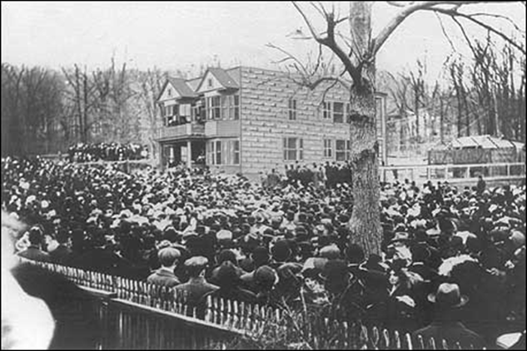
Strikers meet at the Botto House in Haledon, just outside of Paterson,
1913. Courtesy of the Passaic County Historical Society

Hand out 12 continued: What really happened?

The strikers sought to widen their support and fundraising. They staged an innovative “Pageant of the Paterson Silk Strike” in Madison Square Garden in June 1913, to obtain sympathy and support.

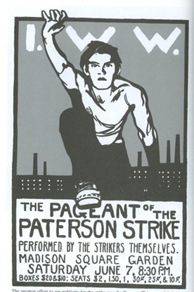
Advertisement for the Pageant of the Paterson Silk Strike,
from The Masses, June 1913

While the Pageant contributed to the united spirit among the workers, it split the leaders: Haywood supported it but Flynn thought that it diverted the workers attention from the real issue-the strike.

The strike turned into an endurance contest. The silk manufacturers had greater resources. They had silk mills in PA and other locations and the strikers were unable to close down mills outside of Paterson. The manufacturers were also supported by other industrialists and most of the newspapers were seeking to halt the growth of the radical IWW. By June 1913, the strikers had used up all personal saving and contributions and were down to one meal a day. The manufacturers ultimately starved the workers back to work after four long months (late February-mid-June, 1913).

Handout 13: Political Cartoon Analysis
The strikers had articles and political cartoons supporting their efforts in labor magazines. Analyze this political cartoon.
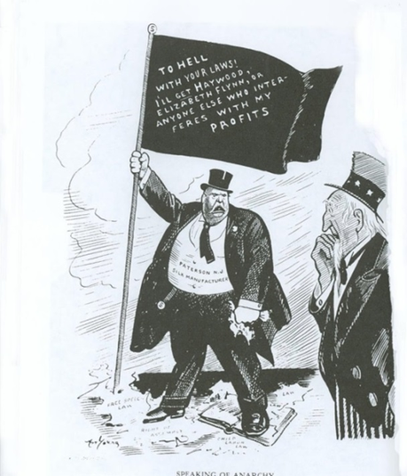
“To Hell with Your Laws,” from Solidarity, June 7, 1913.

Source analysis:
- What is the source?
- What kind of publication if “Solidarity”?
- What would be its viewpoint?
- When was it published?
- Why was it published?

Content analysis:
- What is on the flag?

- Who is the man with the flag? Paterson Silk Manufacturer

- What is the man standing on?

- Who is the man watching?

- What is the cartoon trying to say?

Do you think this is an effective political cartoon? Why or why not?
Handout 14: Questions

- Did the Paterson silk workers and silk mill owners have any common interests? If so, what were they? Could these have been used to achieve a resolution of the workers’ grievances to everyone’s satisfaction?

- Were there ways in which the asymmetrical power relationships between workers and employers in the late 19th and early 20th centuries could have been equalized? How did the Wagner Act of 1935 help to equalize the power of employees and employers?

- Was the 1913 Paterson Silk Strike a failure for the workers? For the manufacturers? For the IWW? For the AFT? Why or why not?

- Discuss the critical role of women in the Paterson Silk Strike? Why were women so involved in the Paterson Silk Strike? Did working class women change their self-perception after taking leadership role sin the strike?

- What roles do unions and government play in regard to American workers today? Labor unions in most European countries are political parties. Here they are lobbyists. Is our system of labor relations working? What might be a better system?

