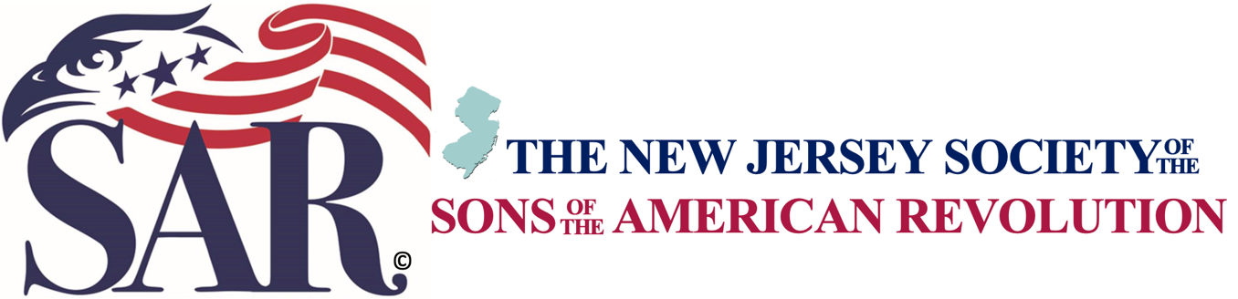

CONTACT: NJSSAR Historian
Roger S. Williams
roger@princetonsar.org
609-389-5657

New Jersey Society of the Sons of the American Revolution
History Teacher of the Year Grants 2021

The New Jersey Society of the Sons of the American Revolution (NJSSAR) invites all teachers in the State of New Jersey, whose approved curriculum teaches students anything about the American Revolution era from 1750 to 1800, to apply for the NJSSAR American History Teacher Grants. The grant is open to all teachers at the elementary, middle school or high school levels at a recognized public, charter, private, or parochial institution. While the preliminary rounds of the grant program begin at the local chapter level, teachers may eventually advance to the state and national levels.

One recipient will be selected as the NJSSAR Reverend John Witherspoon American History Teacher of the Year Grant and will receive potential benefits worth up to $1,500. The John Witherspoon Grant recipient will be entered into the Dr. Tom & Betty Lawrence American History Teacher Award for the National Society SAR. The recipient of the national award will receive potential benefits worth up to $5,000. Two recipients will be selected as NJSSAR William Churchill Houston American History Teacher of the Year Grants and will receive potential benefits worth up to $250.

The NJSSAR American History Teacher Grant recognizes educators who distinguish themselves in teaching the history of the American Revolution. Teacher candidates interested in entering the local New Jersey SAR Chapter grant must complete the required application and submit a written essay of not less than 1000 words discussing the importance of teaching the American Revolution era. The essay may also describe any extra-ordinary teaching techniques or innovative projects utilized by the teacher to teach about any aspect of our history during the American Revolution. The grant is aimed at identifying a teacher who is still actively teaching, has taught for at least three years.

About the National Society of the Sons of American Revolution (SAR): SAR is the largest male lineage organization in the United States and consists of 50 state-level societies with more than 500 local chapters, several international societies, and over 33,000 members. The SAR Mission is to remember our past by honoring those who served or assisted the colonies during the Revolutionary War, promoting core values by protecting our Constitution and perpetuating American ideals and traditions and shaping young minds by educating our youth about the Constitution and those who developed the American ideals and traditions.

