Immigration Policy and its Impact on New Jersey (1840s-today)
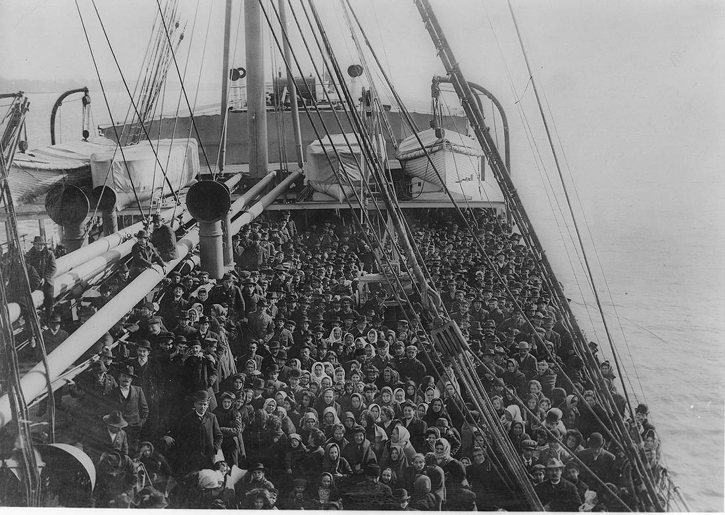
Ship from Liverpool filled with immigrants sailing to Ellis Island. (1907)

This series of lessons may be taught as part of a week-long unit on Immigration or the individual lessons and activities might be integrated as part of U.S. History from 1840 to today.
Lesson Creator: New Jersey Center for Civic Education, Rutgers University, Piscataway
Grade Level: 6-12
Time: Three-Five 45-minute periods
Table of Contents
Page 4: Immigration 1840-1890
Page 5: Immigration 1890-1920s
Page 9: Immigration Restrictions in the 1920s-60s
Page 11: Immigration after the Immigration and Nationality Act of 1965
Page 12: Immigration Today
Page 13: Immigration policies and public opinion
Objective: Students will be able to:
- explain why immigrants decided to leave their homelands and settle in New Jersey in the 19th, 20th and 21st centuries
- compare and contrast the immigration debate in the 1920s to today’s debate about immigration policy
- identify current issues regarding immigration and their impact on New Jersey
- analyze the historical impact of changing U.S. immigration policies on New Jersey

NJ Core Curriculum Content Standards:

6.1.8.D.4.a Analyze the push-pull factors that led to increases in immigration, and explain why ethnic and cultural conflicts resulted.
6.1.12.D.3.b Explain how immigration intensified ethnic and cultural conflicts and complicated the forging of a national identity
6.1.12.D.5.d Relate varying immigrants’ experiences to gender, race, ethnicity, or occupation
6.1.12.A.8.c Relate social intolerance, xenophobia, and fear of anarchists to government polices restricting immigration…
6.1.12.A.11.e Assess the responses of the United States…to the violation of human rights that occurred during the Holocaust and other genocides
6.1.12.A.13.c Determine the extent to which changes in national policy after 1965 impacted immigration to New Jersey and the US
6.1.12.A.14.c Assess the merit and effectiveness of recent legislation in addressing the…citizenship status of individuals and groups
6.1.12.B.14.a Determine the impact of recent immigration and migration patterns in New Jersey and the United States on demographic, social, economic and political issues

Common Core Standards:

RH.6-8.1 Cite specific textual evidence to support analysis of primary and secondary sources.
RH.6-8.4 Determine the meaning of words and phrases as they are used in a text, including vocabulary specific to domains related to history/social studies.
RH.6-8.7 Integrate visual information (e.g., in charts, graphs, photographs, videos, or maps) with other information in print and digital texts.
RH.9-10.1 Cite specific textual evidence to support analysis of primary and secondary sources, attending to such features as the date and origin of the information.
RH.9-10.4 Determine the meaning of words and phrases as they are used in a text, including vocabulary describing political, social, or economic aspects of history/social science.
RH.9-10.7 Integrate quantitative or technical analysis (e.g., charts, research data) with qualitative analysis in print or digital text.
RH.9-10.9 Compare and contrast treatments of the same topic in several primary and secondary sources.
RH.11-12.3 Evaluate various explanations for actions or events and determine which explanation best accords with textual evidence, acknowledging where the text leaves matters uncertain.
RH.11-12.4 Determine the meaning of words and phrases as they are used in a text, including analyzing how an author uses and refines the meaning of a key term over the course of a text
RH.11-12.7 Integrate and evaluate multiple sources of information presented in diverse formats and media (e.g., visually, quantitatively, as well as in words) in order to address a question or solve a problem.
RH.11-12.9 Integrate information from diverse sources, both primary and secondary, into a coherent understanding of an idea or event, noting discrepancies among sources.

Essential Questions:
- Why has New Jersey had a continuing history of attracting foreign-born immigrants?
- What are the push-pull factors that attracted immigrants to New Jersey at various times in the late 19th and 20th centuries and today?
- How has national immigration policy influenced immigration to New Jersey?
- How have immigrants influenced the culture of New Jersey?

Overview

Historians divide the immigration experience into three periods. From 1830-40 to 1880-90 immigration came almost entirely from Ireland, Germany, and Great Britain. This is called the "old" immigration. After 1880 more and more people came from southern and eastern Europe: Poland, Italy, Hungary, Greece, and elsewhere. This is called the "new" immigration, and it lasted until 1925 when Congress for the first time sharply restricted entry into the United States. In 1965, immigration laws were revised and immigration dramatically increased. Since 1965 the major sources of immigrants were Latin America and Asia rather than Europe. These lessons primarily explore the impact of changing national immigration policies on the population of New Jersey.

Vocabulary

      - Anti-semitism--prejudice against, hatred of, or discrimination against Jews as a national, ethnic, religious or racial group
      - Benefits –strengths of alternative actions that can be taken
      - Chain Migration--One immigrant sponsors several other immigrants for admission, who then sponsor several others themselves, and so on.
      - Civil unrest—public disturbances caused by political, labor or other issues
      - Costs-weaknesses of alternative actions that can be taken?
      - Emigrant—a person who leaves one country or region to settle in another
- Ethnicity-- a socially defined category of people who identify with each other based on a common ancestral, social, cultural or national experience
- Famine—extreme scarcity or shortage of food
- Immigration—the process or action by which individuals come to live permanently in a foreign country
- Indentured Servant—An immigrant who entered into a contract to work for someone for a specified term—usually five to seven years-- in exchange for transportation and the prospects of a job and a new life in the American colonies
- Land reclamation--the process of creating new land from ocean, river or lake beds either by filling the area with rock, cement and then clay and soil (land fill) or by draining submerged wetland
- Migration-- the movement by people from one place to another with the intention of settling temporarily or permanently in the new location
- Opportunity Costs—value of the best alternative forgone (what you give up) in a situation in which a choice needs to be made between several mutually exclusive alternatives given limited resources (e.g., to stay or to go)
- Political freedom-- state of being free from government oppression.

Activities/Procedures

1. Immigration 1840-1890

- Castle Garden Immigration Center, New York

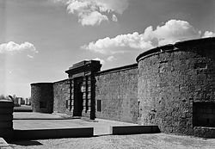
Castle Clinton (formerly Ft. Clinton and Castle Garden), at Tip of Manhattan

- Background: Before Ellis Island was built, immigrants came to the United States through several state locations. The first immigration station established in the United States was at Castle Garden, which had originally been built in 1811 as a fort (Ft. Clinton) at the southern tip of Manhattan to protect New York Harbor and was turned over to the State of New York in 1824 and turned into an entertainment facility for the next 32 years. It 1855 it became New York’s first official immigration processing center and the point of entry for many who settled in New Jersey. Between 1855 and 1890, more than 8 million people arrived in the U.S. through Castle Garden. The building is now a national monument, Castle Clinton, operated by the National Park Service in Battery Park, New York City.

- Photo Analysis Activity: Look at the image of immigrants at Castle Garden in 1866 (Handout 1). What is the source? Is it reliable? What is the image showing? What is the language on the signs? (German) What does this image tell us about immigration in the 1860s in the New York area? (Many were from German-speaking countries!)

- Critical Thinking Activity: Why did immigrants come to NJ and the U.S. as indentured servants?

- Background:
- Beginning in the 1840s, immigration to New Jersey increased dramatically. About 80 percent of these new arrivals were from Germany and the British Isles, primarily Ireland.
- There were many reasons why these immigrants left their homeland to come to the United States.
- For the Irish, the Potato Famine which lasted from 1845-1851, was the most common reason for them to leave. As the Irish farmers moved from their unproductive farms to overcrowded cities where they could not find employment, poverty pushed many to leave for decades afterwards.
- For the German, most came to the United States for political freedom after the 1848 Revolution in the (not yet unified) German states and to avoid the economic hardship caused by the civil strife.
- These new immigrants often faced discrimination in the United States as they supplied the needed manpower for the state's growing industries in Newark, Jersey City, Paterson, Trenton and Camden.
- Narrative writing activity:
- Draw conclusions: What factors pushed individuals to leave Ireland in the 1840s-60s? What factors pushed people to leave Germany during this time period? Why did many of them settle in New Jersey during this time period? What were some of the challenges that both faced during their journey to the United States?
- Imagine that you are an Irish or German immigrant who arrived in NJ in the 1850s and write a letter to a friend who is planning to emigrate to NJ from Ireland or Germany explaining the challenges you have faced, the benefits you have gained and offer advice.

- The impact of technology

  - Beyond the “push” and “pull”, technology had an impact on immigration.
  - Background:
  - The simple innovation of sailing on a schedule gave immigrants and the American economy a boost in the early 1800s. Traditionally, ships sailed when they had loaded enough cargo to justify a voyage. Passengers could be delayed days or even weeks waiting for the holds to fill. After the War of 1812, ship owners began experimenting with regular timetables, and the 1820s and 1830s saw a boom of scheduled shipping lines across the ocean and along the coasts. Sailing across the Atlantic took 1-2 months, depending on weather.
- By the 1840s, steamships cut the trip across the Atlantic from 1-2 months to 8-14 days, making immigration to the United States from Europe much quicker, easier and less expensive.
- However, for many it was still a long and arduous journey. Just to get to a port of embarkation might mean days or weeks of travel on foot, by rivercraft, or in horse-drawn vehicles
- Compare the 1840s and today: Would you be willing to spend 1-2 months on a sailing ship to emigrate to another country? Compare travel in the 1840s with travel today? How do most immigrants come to the United States in the 21st century?

- Immigration 1890-1920s

  - Ellis Island Primary Source Photo Activity

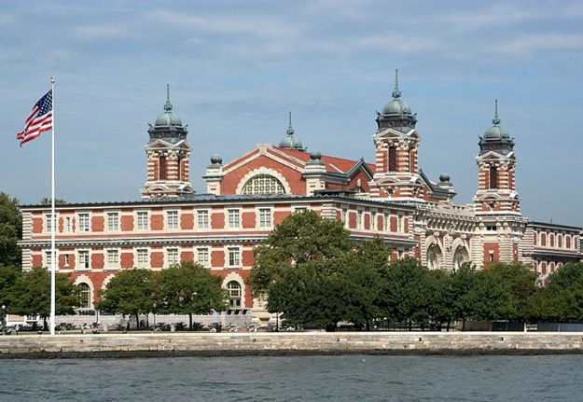

- Background:
- The Immigration Act of 1891 moved the burden of processing new immigrants from the states to the federal government and authorized the construction of an immigration facility at Ellis Island in New York Bay. The island, which was expanded with reclaimed land from dredging, is owned partially by the state of New York and partially by the state of New Jersey.
- After the rigors of the voyage, immigrants landed at Ellis Island in New York harbor. There they were questioned, processed, inspected for diseases, and then admitted to the country. As in earlier years, a disproportionate number settled in New Jersey.
- Between 1880 and 1920, immigration to New Jersey was predominantly from central and southeastern Europe, particularly Italy, Poles, Russian Jews, Greeks, Czechs (Bohemians), Finns, Armenians, Hungarians, Latvians, and Lithuanians.
- Photo analysis activity: What can we learn about immigration by looking at images?
  - Divide the class into five groups and have each group look at one of the following photographs:
- Handout 2: Emigrants coming to the “Land of Promise,” 1902—LC-USZ62-7307 at http://www.loc.gov/resource/cph.3a09957/
- Handout 3: Landing at Ellis Island, 1902—LC-USZ62-12595 at http://www.loc.gov/item/97501086
- Handout 4: At Ellis Island, 1900 LC-B2-5338
- Handout 5: Immigrants from Foreign Countries at Ellis Island, 1904—LC-USZ62-40104 at http://www.loc.gov/resource/cph.3a40445/
- Handout 6: US Inspectors examining eyes of immigrants, 1913—LC-USZ62-7386 at http://www.loc.gov/item/97501532/
- Jigsaw and have each group explain what its photo tells us about the experience of coming to America as an immigrant at the turn of the 20th century (1890-1920)
- Draw conclusions based on consideration of all five images.

  - Comparison of 1880 and 1920

- Background: After 1880 the percentage of Irish, British, and Germans began to drop as conditions in those countries became more settled. At the same time, immigration from southern and eastern Europe-from Italy, Poland, Russia, and the Austro-Hungarian Empire-began to rise.
- What “pushed” individuals to leave southern and eastern Europe after 1880?
  - The unification of Italian states in 1861 led to political and social unrest and a tax burden on the southern area where the soil was already depleted. Many sharecroppers, tenant farmers, and small business and landowners chose to emigrate rather than face the prospect of a deepening poverty.
  - The unification of the German states by Prussian Chancellor Otto von Bismarck in 1871 pushed Catholics from southern Germany to leave in the face of religious oppression.
  - Growing ethnic tension and required army conscription led many in the Austro-Hungarian Empire to leave.
  - Anti-semitism and programs in Russia drove millions of Jews to leave the Russian Empire.
- What “pulled” émigrés to the U.S., and especially to New Jersey after 1880?
- Industries were actively recruiting workers from eastern and southern Europe to fill the labor shortage that existed in the years following the Civil War, as industrialization spread.
- Economic growth attracted immigrants, and the arrival of new workers, in turn, quickened the pace of industrialization. Immigration, then, was both a cause and an effect of economic growth. An expanding economy provided increasing numbers of jobs at every skill level.
  - Why New Jersey? Adjacent to ports of entry, New Jersey quickly developed a large immigrant presence.
  - Chart activity: compare the state's largest immigrant groups in 1880 with those in 1920 as shown in Handout 7. How did immigration after the Civil War change the face of New Jersey?
  - While the British, Irish, and Germans were still the major sources of immigration to New Jersey in 1880, they were much less prominent forty years later.
  - By 1920, Italians constituted by far the largest immigrant group, Germans the second largest, Poles the third and Russian Jews the fourth.

  - Where did the new immigrants go in New Jersey, 1870-1920?

- Background: Where did the immigrants settle in New Jersey and why? Immigrants settling in New Jersey entered a dynamic economy with an expanding industrial base and a constant demand for skilled and unskilled labor. They found work in the steel, tobacco, and pencil factories of Jersey City; in the leather and textile works of Newark; in the silk mills of Paterson; and in the potteries of Trenton. They laid railroad and streetcar track, dug the Since 1870 there has been heavy immigration to urban centers, including Newark, Hoboken, Jersey City, Paterson, Passaic, Perth Amboy, Trenton, and Camden water and sewer ditches required by booming cities, and unloaded freight from railroad cars, canal boats, barges, and steamers.
- Map activity: the development of New Jersey’s cities. Use Handout 8: Map of New Jersey with the location of its largest cities in 1870. Divide into eight groups and have each group find information about the development of one of the following cities:
- Camden
- Newark
- Hoboken
- Jersey City
- Passaic
- Paterson
- Perth Amboy
- Trenton
Have the groups jigsaw or share with the rest of the class. Discuss and conclude why population centers developed where they did (rivers, ports, etc.—jobs)

  - Case Study of Italians (or select another ethnic group) coming to New Jersey—1880-1920

- Research activity: Have students select an ethnic group and conduct a short research project to identify where Italian (or other) emigres to New Jersey settled, why they settled there and what challenges they faced. Make a brief oral or visual presentation.
- Background: Whenever possible, individuals from Italy emigrated to a place where someone they knew, either kin or neighbor, had already settled. People intending to emigrate carefully planned to link up with someone who would help in finding work and lodging. Few people sailed off into the sunset alone. Most joined relatives or villagers who had successfully gone before.
- From 1880 to 1920, an estimated 4 million Italian immigrants arrived in the United States, the majority from 1900 to 1914. Once in America, the immigrants faced great challenges. Often with no knowledge of the English language and with little formal education, many of the immigrants were compelled to accept low-wage manual-labor jobs, and were frequently exploited by the middlemen who acted as intermediaries between them and the prospective employers. Many sought housing in the older sections of the large northeastern cities where they settled, that became known as “Little Italies”, frequently in overcrowded substandard tenements which were often dimly lit with poor heating and ventilation.
- Italians in Newark grew from 400 in 1880 to 27,000 in 1920, 15% of the city’s population. Ethnic clustering created ethnic neighborhoods. Here immigrants could continue familiar customs and ways. In Newark's The "New" Immigration, 1880-1920 41 crowded First Ward, Italian immigrants could deal only with other Italians and satisfy all their daily needs. Boarding houses catered to new arrivals from Italy, easing their entry into American society. Street vendors with pushcarts or horse-drawn wagons sold fruits and vegetables. Small groceries occupied the ground floors of comer tenements. One observer in the 1930s wrote of their "cheeses, garlic, salami and red pepper hanging from the rafters, . . . over 150 different types of macaroni,"
- Italians generally were unskilled laborers. By 1890, half of the laborers who maintained the railroad tracks between New York and Philadelphia were Italian, rapidly replacing the Irish. "Industry in New Jersey," one historian has written, "developed a rough caste system in which ethnic origin largely determined one's position in the occupational hierarchy." At the top, as owners and managers, were native white Americans. In the middle, as foremen and skilled workers, were Irish, German, and British.

e. Ethnic tensions

- Background: Immigration to the United States after the Civil War (1880-1920) created a society that was both increasingly diverse and increasingly uncomfortable with that diversity. Today we celebrate American pluralism, our self-proclaimed ability to harmonize divergent cultures with minimal discord. Nineteenth-century Americans did not seek or value pluralism. Instead they labeled many of the religious beliefs and social practices that immigrants brought with them as threats to "American" values and culture.
- What were the sources of the ethnic tensions?
- Religious differences. Since the Reformation in the sixteenth century, European Protestants and Catholics had distrusted and disliked each other. Between 1500 and 1800, Europeans went to war on several occasions over religious issues. In Protestant nations, Catholics were viewed as potential subversives, as were Protestants in Catholic nations. Protestant English colonists brought their suspicions and fears to America. Their nineteenth-century descendants, schooled in these traditions, viewed the Catholic Church as an alien force that threatened the foundations of religious freedom and democratic order. A New Jersey Dutch Reformed minister wrote in the 1850s that Catholicism was "subversive alike of civil liberty, freedom of conscience, and the purity of Religion."! Until 1844 the New Jersey state constitution only allowed Protestants to hold public office.
- Nativism. Fear that immigrants would take away jobs from “Natives” and bring down wages.
- Belief in the “racial” (race was used for ethnicity in this period) inferiority of southern and eastern European immigrants and they supposedly lacked the Anglo-Saxon gift for democratic self-government and therefore to be incapable of assimilation.
- Fear of political radicalism. The native-born blamed most labor discontent on "foreign" political and economic ideologies imported by immigrants. They felt particularly threatened by Socialists, who rejected private ownership of profit-making property, and Anarchists, who rejected most government. Strikes and other disorders were often blamed on them. Anarchists and Socialists were also condemned for questioning the basic fairness of the economic system and the distribution of wealth and income.
- The Nativist or Know Nothing Party supported these views
- These arguments helped fuel the movement for immigration restriction, which gained strength in the early twentieth century.
- Political cartoon analysis: Look at Handout 9: Political Cartoon from Puck magazine, 1889. In In the late 19th Century, long before Mad Magazine and the Daily Show, there was Puck. The magazine helped to change the very nature of political cartooning, was at the forefront of printing technology and agitating for progressive causes during the Gilded Age. Who is the woman wrapped in the American flag stirring the “teacup” of citizenship? (The U.S.) Why is she using a spoon marked “equal rights”? Who is the man holding a flag and a dagger? (a radicalist). Who would be today’s “radical”? (Terrorists) Look at the faces of the others in the teacup? Do you see ethnic looking individuals? Yes, a German-looking man with a Prussian helmet. A French or Italian with a beret-type hat. What is the cartoon trying to say?

3. Immigration Restrictions in the 1920s-60s

        - Background
- Until the 1920s, immigration was open to almost everybody (i.e., any European who wanted to come to the U.S.) with the following exceptions:
- 1875 Immigration Act excluded prostitutes, convicts and Chinese contract workers
- 1882 Chinese Exclusion Act
- 1891 Immigration Act excluded idiots, insane persons, paupers, diseased persons, felons, polygamists
- 1907 “Gentlemen’s Agreement” limited number of Japanese immigrant laborers
- 1907: Congressional Dillingham Commission report: new immigrants from eastern and southern European harder to assimilate; immigration should be restricted by nationality
- 1896, 1913 and 1915: Congress proposed a literacy test
- 1917: Literacy test passed over President Wilson’s veto
- Responding to the fears of anarchist immigrants and the recession of 1920-21 as well as fears by Native-born Protestants that they would soon be overwhelmed in their own land, Congress saw itself as fighting to preserve an embattled Anglo-Saxon tradition and passed an Emergency or Temporary Quota Act that established for the first time quotas restricting immigrants from Southern and Eastern European countries.
- The 1921 law reduced total annual immigration to the U.S. from 800,000 to 300,000 a year.

        - Historical roleplaying activity--The National Origins Act
- A major national debate occurred in 1923-24 over the provisions of the Johnson-Reed bill (which became the National Origins Act of 1924) to impose permanent restrictions or quotas on immigration by nationality:
- Restrictions were supported by the American Federation of Labor, the American Legion , the Ku Klux Klan and the Immigration Restriction League. They were opposed by Congressman such as LaGuardia from New York City, the National Association of Manufacturers, the U.S. Chamber of Commerce and the Federal Council of Churches
- Students roleplay groups supporting and opposing immigration restrictions in the 1920s and try to negotiate a solution, using the chart attached as Handout 10.
- After debriefing the roleplaying, students compare the results of their historical roleplaying with what really happened in history:
- The National Origins Act was passed and signed into law in 1924 severely restricting immigration from southern and eastern Europe:
- It banned immigration from east Asia entirely.
- It reduced the quota for European immigrants to two percent of the population from that country in the United States in the 1890 census (In 1927, the basis was changed from 1890 to 1920).
- It made the restrictions permanent.
- Quotas were based on the number of people in the United States who were descended from each European nationality.
- Thus new immigrants were to be admitted in a rough ratio with those already here. To establish quotas it used population figures for 1890, before most southern and eastern Europeans had entered the country. This further reduced immigration from those nations
- The law was revised in 1927 to base its calculations on the more recent 1920 census, and thus liberalizing the number of immigrants allowed from eastern and southern European countries.
- Students consider what options were possible in the 1920s.

        - The impact of the National Origins Act: Case Study of the impact of the National Origins Act on German-Jewish Immigration, 1920s-40s

- Background: Why did the Jews from Germany want to immigrate to the U.S. in the 1930s and 40s?
- In the 1930s events in Germany forced thousands of German Jews to leave their homes as Adolf Hitler came to power and blamed Jews for the troubles (unemployment, poor economy) in Germany. Many came to the United States.
- Hitler had made Anti-Semitism part of his government’s policy
- After 1938 the German government seized most Jewish owned property.
- Hitler’s government began to move Jews to concentration camps where the conditions were terrible and many died.
- What were some of the challenges the Jews faced during their journey to the United States?
- Not all attempts to escape were successful because of the immigration quotas in place in the U.S. at the time limited the number of people who could immigrate from Germany and other European countries.
- The St. Louis: Look at Handout 11 and review the story of the St. Louis.
- How would you have felt if you had been on that ship?
- The National Origins Act had severely limited the number of Jews from Eastern Europe and Germany who were allowed into the US immediately before and during World War II. The President or the State Dept. could have intervened and increased this number, but they did not.
- So when the St. Louis reached Havana, Cuban govt. refused to allow most of the refugees to come on land. The ship sailed up the coast of Florida with the U.S. Coastguard following to make sure that no one tried to swim ashore.
- The State Dept. refused to allow the refugees to land without special legislation or executive order. The U.S. was not yet at war with Germany. Neither legislation nor an executive order was forthcoming.
- The St. Louis returned to Europe where several nations, such as the Netherlands, did allow asylum to some of the refugees. But Germany later invaded these countries and most of the ill-fated passengers were sent to concentration camps where many died.
- Narrative writing Activity:
- What were some of the challenges the Jews faced in the US? Imagine you are a German Jewish immigrant who arrived in NJ in the 1940s. Write a letter to a friend who is planning to emigrate to NJ from Europe. Explain the challenges you have faced and offer advice. Many managed to come to the U.S. and most of them settled in the New York area, which included NJ.
- What are some ways the Jews helped NJ and America? (Einstein)
- What are some examples of culture that the Jews brought to the US? (music, movies)

- Immigration after the Immigration and Nationality Act of 1965

- Background:
  - Entry into World War II forced the United States to shift its immigration policies to support its allies and its war supply needs.
  - Immigration policy was used to cement international relations, e.g., by opening immigration and citizenship to Chinese in 1943, the US bolstered its alliance with Chiang Kai-Shek’s China.
  - While the doors were finally opened for Chinese, 120,000 persons of Japanese ancestry (two-thirds of them U.S. citizens) were interned in camps for fear that they would be spies or collaborators.
  - While 400,000 persons of Mexican descent (an estimated half of them U.S. citizens) had been repatriated during the Depression of the 1930s because they failed to enter with proper visas or other violation of U.S. laws or regulations, during World War II, Mexican workers were granted temporary relief from immigration quotas under the “bracero” (“day laborer”) program. This program continued after the war.
  - In 1948 Displaced Persons Act admitted 400,000 Europeans uprooted by war.
  - With less immigration, a more homogeneous society briefly emerged in the post-World War II period (1947-1965)
  - Immigrants from Puerto Ricans (who were not restricted under the 1920 National Origins Act—Puerto Ricans were, in fact, migrants rather than immigrants since Puerto Rico was and is a territory of the United States) began immigrating to New York City and industrial centers in nearby Hudson, Essex and Passaic counties in New Jersey. Puerto Rico underwent an economic upheaval after World War II that disrupted its traditional agricultural society. Disruption set people adrift, and these were the people most likely to become migrants, willing to seek work and a more secure life outside of Puerto Rico. Between 1950 and 1980 the number of Puerto Ricans in New Jersey rose from under ten thousand to more than 240,000. In 1980 57 percent lived in Hudson, Essex, and Passaic counties.
  - Responding to growing efforts to change the 1920s immigration policy, the Immigration and Nationality Act of 1965 was enacted, which:
    - Abolished national origins quotas and gave preference to skilled workers and immigrants with close relatives in the U.S.
    - Set overall limits for immigration from Western and Eastern hemispheres.
- Congress had anticipated that most immigrants would continue to be Europeans. However, general improvement in European economy, worsening conditions in Latin America and war in Vietnam, together with system of family preferences, resulted in greater number of immigrants from Asia and Latin America in 1970s and 80s.

- Census data activity: Use the census data to compare the growth of foreign-born residents as a percentage of the state population (Handout 12) with the changing national immigration policies and draw conclusions about the impact of immigration policies on the nature of the population of New Jersey.

- Critical thinking activity: Take a position and support it
Chain migration happens because present U.S. immigration policy is based on the principle of broadly defined family reunification; immigrants are able to sponsor their relatives back home to be admitted as immigrants here. Under the "immediate relatives" category, the parents, spouse, and children of a U.S. citizen are admitted without limit. Therefore, once the law was changed in 1965 to create the so-called family reunification system, chain migration caused the numbers in this category to steadily rise.

Do you think family reunification is a good basis to accept immigrants? Why or why not?

- Immigration Today

- Background
- The 1996 Immigration Act doubled the size of the border patrol, authorized the construction of barriers along the US-Mexican border and made illegal immigrants ineligible for most governmental benefits.
- Since 1997, the United States has been admitting approximately 900,000 legal immigrants a year.
- Another 300,000 people illegally cross the borders annually.
- By 2007 the number of illegal immigrants in the US leveled off at about 11 million
- The majority of illegal immigrants live in Arizona, California, Florida, Illinois, New York and Texas, but New Jersey has many also
- Numerous efforts have been made in Congress to enact a bill to reform US immigration policy (increasing border security, legalizing illegal immigrants, providing a temporary worker program and a family and merit-based visa program to reduce the backlog of those waiting and set up a new point system) but none has succeeded.
- Federal inactivity has sparked local and state initiatives to deny illegal immigrants benefits (CA law struck down by court), limit the actions of day laborers or provide in-state tuition for the children of illegal immigrants when the Dream Act, which would have given legal status and a chance for citizenship for those who came to the U.S. as minors, failed to pass even though the Senate supported it 55 to 41 because of the filibuster need to 60 votes in Dec. 2010
- Some colleges and universities have decided to accept young people who came to the US before age 16, lived there and graduated from a U.S. high school or received a GED in-state tuition.

- Impact in New Jersey
- New Jersey has one of the most diverse populations in the country. According to the 2010 census, the racial makeup of the state is 68.6% white, 13.7% African American, 0.3% Native American, 8.3% Asian American, 6.4% other races and 2.7% multiracial. 17.7% of the population is Hispanic or Latino.
- New Jersey has the second largest Jewish population by percentage (after New York); the second largest Muslim population by percentage (after Michigan); the largest population of Peruvian Americans in the United States; the largest population of Cubans outside of Florida; the third highest Asian population by percentage; and the third highest Italian population by percentage, according to the 2000 census.
- Today’s immigrants to New Jersey are coming from India (10%), Mexico (6.7%) and the Philippines (4.9%).
- Look at the chart by county (Handout 13) and identify those counties that have growing immigrant populations (Hudson, Middlesex, Bergen, Passaic and Essex Counties) and those that have small immigrant populations (Cape May, Salem, Gloucester and Ocean Counties). Have recent immigrants primarily been attracted to north or south Jersey (North). Why do you think this is the case?

- Immigration policies and public opinion

- Form a Continuum, Take a Stand, Listen to other views and perhaps change your views
  - Ask students who believe that we should be allowing greater number of immigrants to enter the country and providing a path to citizenship for those who entered the country without proper documentation to stand to your right and those who do not agree to stand to your left.
  - Then ask them to explain their positions and move students to places that reflect their views from strong support to strong disagreement.
  - Students cannot interrupt the person speaking.
  - As students explain their view, ask others if they would like to change their positions based on what they heard.
  - This is a listening activity designed to make students consider the reasons for their political views and to consider other views.

- Political Cartoon Analysis
  - Have students look at the recent political cartoons about immigration (Handout 14), all but the first one from New Jersey newspapers.
  - What do you see in each cartoon? What is the message that the cartoon is trying to convey
1. Deutsch—US history is rife with negative views about immigrants, in 1780, 1850, 1920 and today
      - Drew Sheneman, The Newark Star-Ledger, 2012—Unclear if the man blaming immigrants for taking our jobs and resources is Uncle Sam or NJ Governor Christie since he looks a lot like Gov. Christie
      - Jimmy Margulies, The Record, 2013—It’s a rough path to citizenship because it has to go through the Congress
      - Drew Sheneman, The Newark Star Ledger, 2014—Making fun of ideas to deport immigrants
- Do you think that these cartoons express the opinions of most people in New Jersey?

Assessment

- Select three of the following topics for short essays:
- Compare the issues involved in the immigration debate in the 1920s and those today.
- What has the impact of the 1965 immigration act been on New Jersey? The 1983 immigration reform act?
- Who should be a citizen and why?
- Could you pass the Citizenship test?
- Explain why it is important to understand the perspectives of the many cultures in New Jersey.
- Project: Identify the issues involved in immigration reform and research and draft legislation to address these issues (Would your family qualify for citizenship under your policy? Send it to your members of Congress)

Extension

- Visit Ellis Island. During the island's 62 years of operation (1892-1954), over 12 million immigrants were processed at Ellis Island. Following restoration in the 1980s, the Great Hall immigration processing building reopened as the Ellis Island Immigration Museum, a symbol of this nation's immigrant heritage. The museum exhibits chronicle Ellis Island's role in immigration history, in the context of four centuries of immigration to America. Ellis Island is run by the National Park Service. It is open every day except December 25. Ellis Island can only be reached by ferries, which run on a regular schedule from Battery Park, NY, and Liberty state Park, NJ. For additional information go to http://www.nps.gov/elis/index.htm.

- Consider the history of Ellis Island. An interstate compact had been signed between New York and New Jersey prior to Ellis Island becoming a major immigration center. This compact granted New York the rights to all islands in the water channel separating the two states (including both Ellis Island and the much larger Staten Island), but granting New Jersey the rights to half of the water channel. This agreement was fashioned in order to allow New Jersey to build docks on the riverfront, while allowing New York to control islands that it already considered integral parts of its territory. This led to places such as Ellis Island located on the New Jersey half of the river, but belonging to New York. Later, Ellis Island was expanded through land reclamation and soon became a major center for immigrants coming from Europe to the United States. This land was added by New York and operated by New York for decades.

In a lawsuit brought to determine which state “owned” Ellis Island, the U.S. Supreme Court ruled in New Jersey v. New York, 523 U.S. 767 (1998), that since the land added was not expressly granted to New York by the interstate compact and was in water that had been expressly granted to New Jersey, the reclaimed land belonged to New Jersey. All land originally given to New York by the compact (the original, natural Ellis Island) remains under the jurisdiction of New York, The two states jointly negotiated a post-trial settlement to decide exactly where and how to draw the lines on the 27.5 acre-island in accordance with the Supreme Court decision. While the court decision has changed the state control and jurisdiction of most parts of the island, the actual current landowner is the federal government.

Although New Jersey owns 90% of the land mass, the Great Hall is on the New York portion and most sales taxes go to New York. The New Jersey area includes the unrestored Ellis Island Hospital Complex, built in 1909, which was one of the first and largest public health hospitals in the United States, with 725 beds, a powerhouse, a laboratory and housing for doctors and nurses, kitchens, laundries and recreation facilities. Save Ellis Island is an effort to raise funds to restore these facilities and to provide programs about them and in them. For more information go to http://www.saveellisisland.org/

- Can you pass the citizenship test? Immigrants who have been permanent residents for at least five years may become citizens. They must complete naturalization papers, meet with an officer of the U.S. Immigration and Citizenship services and take and English and civics test. The English test has three components: reading, writing, and speaking. The civics test includes basic questions about important subjects in U.S. history and government. Can you answer the civics questions correctly? For the 100 questions, ten of which may be asked on the civics exam, go to http://www.uscis.gov/citizenship/learners/study-test .

Additional resources:

- New Jersey State Library at http://www.njstatelib.org/research_library/new_jersey_resources/digital_collection/unit_9_world_war_i/
- Cohen, David Steven. New Jersey Ethnic History: A Bibliography. Trenton, New Jersey: New Jersey Historical Commission, 1986.
- Cunningham, Barbara, ed. The New Jersey Ethnic Experience. Union City, New Jersey: William H. Wise & Co., 1977.
- Wacker, Peter O. Land and People: A Cultural Geography of Preindustrial New Jersey: Origins and Settlement Patterns. New Brunswick, New Jersey: Rutgers University Press, 1975.

Handout 1
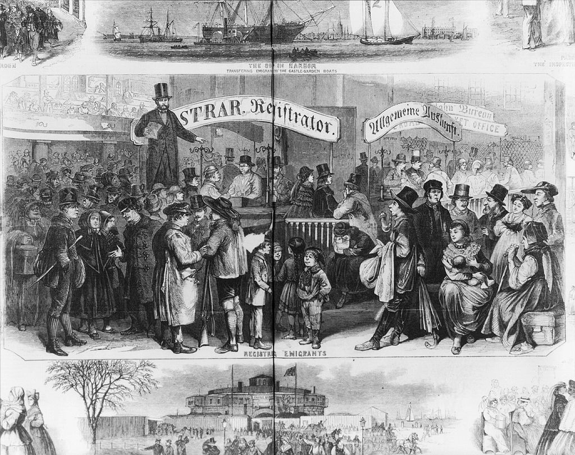
Immigrants at Castle Garden, New York City, 1866.

From The Library of Congress Prints and Photographs, originally from a wood engraving in
"Frank Leslie's Illustrated Newspaper", 20 January 1866, vol. 21, p. 280-281.
Handout 2

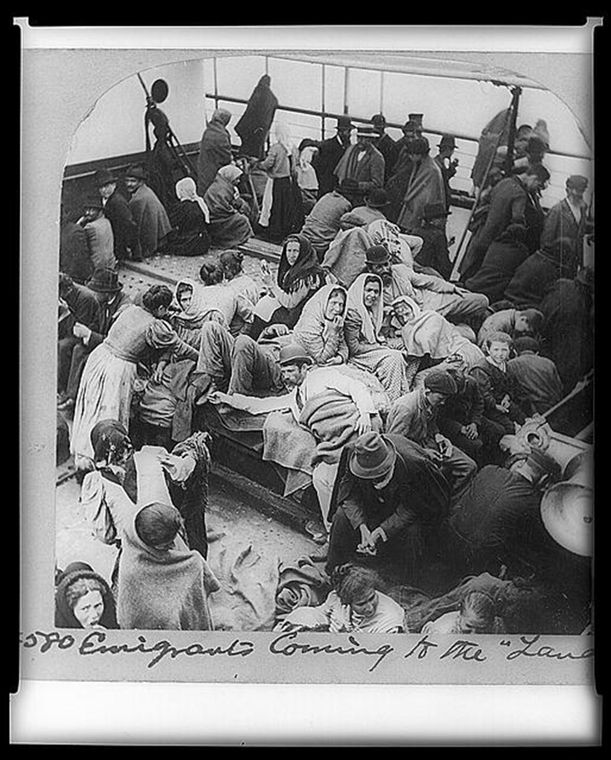
Emigrants aboard ship to the “Land of Promise,” 1902
LC-USZ62-7307

Handout 3

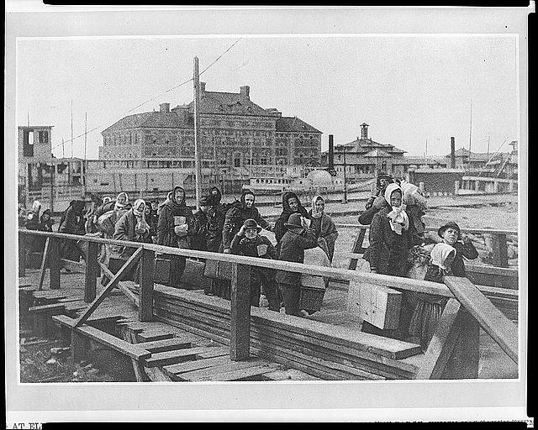

Landing at Ellis Island, 1902
LC-USZ62-12595

Handout 4

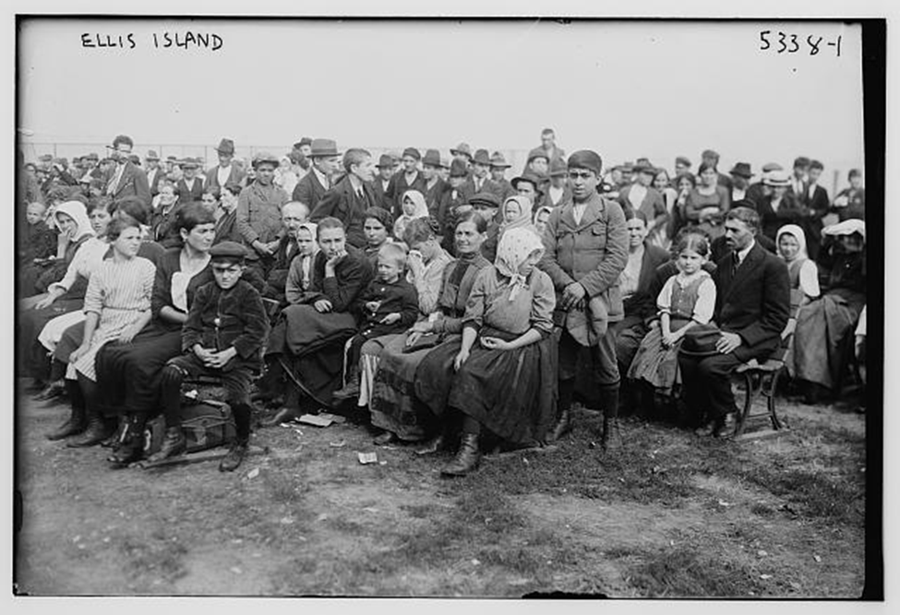

At Ellis Island, 1900
LC-B2-5338

Handout 5

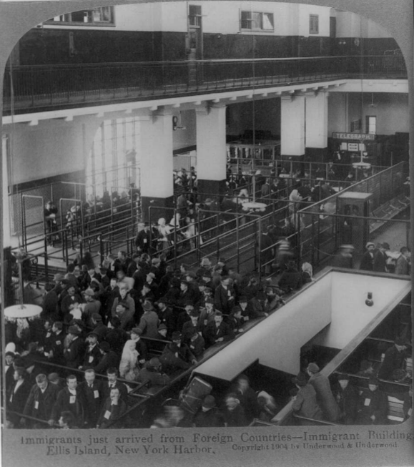

Immigrants arrived from Foreign Countries at Ellis Island, 1904
LC-USZ62-40104

Handout 6

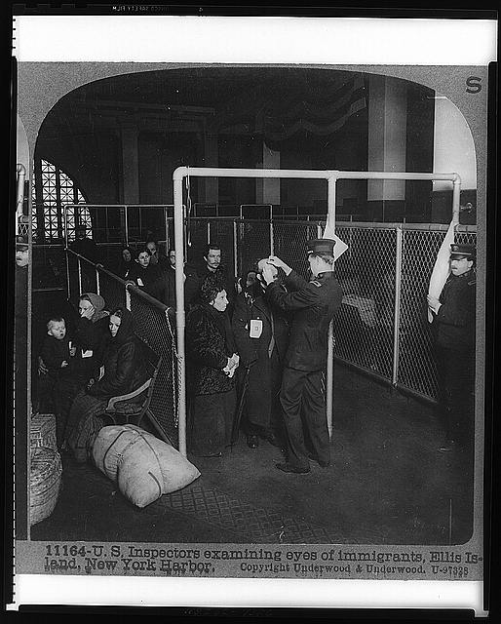

U.S Inspectors examining eyes of immigrants, Ellis Island, 1913
LC-USZ62-7386

Handout 7

Immigration to New Jersey, 1880 and 1920

Percentage of immigrants in NJ  1880 |  |  | Percentage of immigrants in NJ  1920
Ireland | 42% |  | Italy | 21.3%
Germany | 29.3% |  | Germany | 12.5%
Great Britain | 18% |  | Poland | 12.2%
Holland | 1.9% |  | Russia | 10%
France | 1.7% |  | Ireland | 8.9%
 |  |  | Great Britain | 8.9%

Sources: U.S. Census, 1880 and 1920

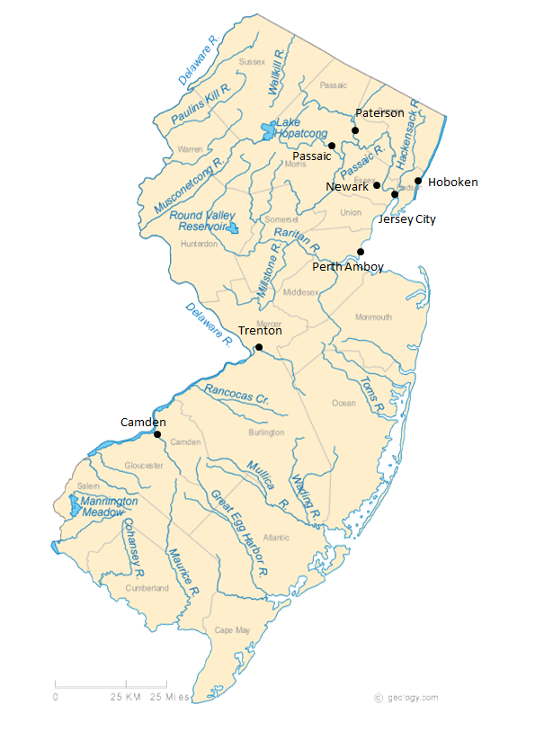
Handout 8

Handout 9
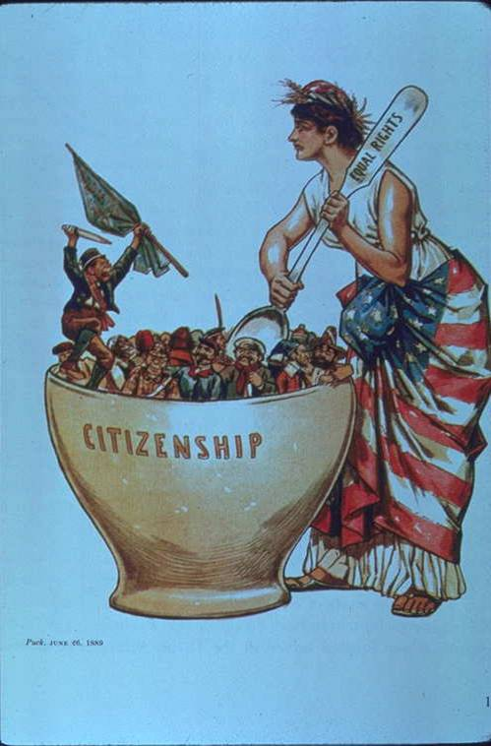
Political Cartoon fror the magazine Puck, 1889

Handout 10
Immigration Quotas proposed In 1923
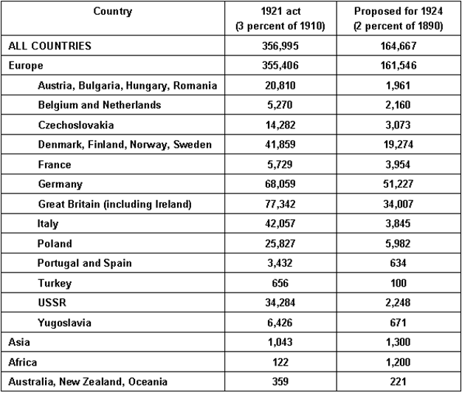

Source: Immigration and Naturalization Service

Handout 11

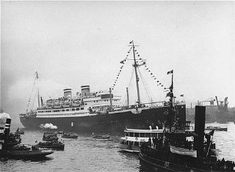
This is a picture of the St. Louis, a passenger ship which left Germany in 1939 with nearly 1000 refugees, most of them Jews who had qualified for but not yet received American visas, and then arranged for temporary Cuban visas.

Handout 12

Foreign born Population fo New Jersey

Year | Total NJ Population | Percent Foreign Born
1870 | 906,096 | 20.85%
1880 | 1,131,116 | 19.60%
1890 | 1,444,933 | 22.77%
1900 | 1,883,669 | 22.93%
1910 | 2,537,167 | 25.94%
1920 | 3,155,900 | 23.40%
1930 | 4,041,334 | 20.90%
1940 | 4,160,165 | 16.80%
1950 | 4,835,329 | 13.05%
1960 | 6,066,782 | 10.15%
1970 | 7,171,112 | 8.85%
1980 | 7,364,823 | 10.23%
1990 | 7,730,188 | 12.50%
2000 | 8,414,350 | 17.55%
2010 | 8,791,894 | 20.10%
2013 | 8,899,000 (est.) | 21.20%

Handout 13
New Jersey
Percent Foreign Born by County

 | 1990 | 2000 | 2012
Atlantic | 6% | 12% | 16%
Bergen | 18% | 25% | 29%
Burlington | 5% | 6% | 9.5%
Camden | 4% | 7% | 10%
Cape May | 3% | 3% | 5%
Cumberland | 4% | 6% | 10%
Essex | 16% | 21% | 24.5%
Gloucester | 3% | 3% | 5%
Hudson | 31% | 39% | 41%
Hunterdon | 5% | 6% | 8.5%
Mercer | 9% | 14% | 20%
Middlesex | 14% | 24% | 39%
Monmouth | 8% | 10% | 13%
Morris | 11% | 15% | 19%
Ocean | 6% | 6% | 8%
Passaic | 19% | 27% | 27.5%
Salem | 2% | 3% | 4%
Somerset | 11% | 18% | 23%
Sussex | 5% | 6% | 7%
Union | 18% | 25% | 29%
Warren | 4% | 6% | 9%
Handout 14: Political Cartoons
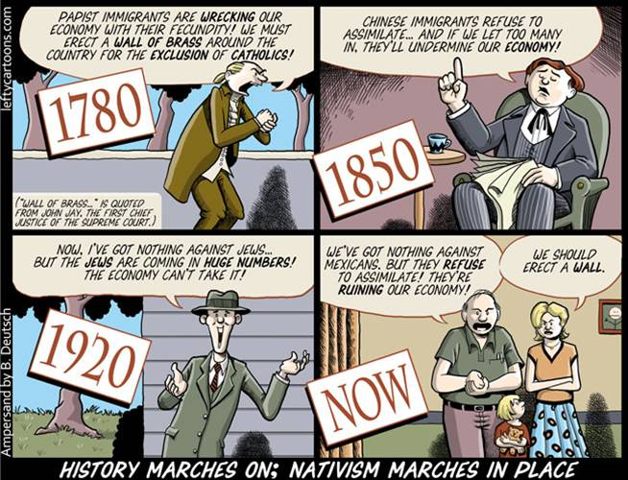
Ampersand by B. Deutsch
http://www.dollarsandsense.org/archives/2007/1107toon.html

Drew Sheneman
The Newark Star-Ledger, 2012
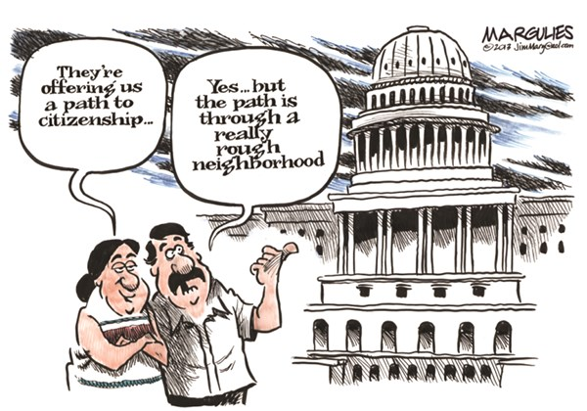
Jimmy Margulies
The Record of Hackensack, NJ 2013

Drew Sheneman
The Newark Star-Ledger, 2014

