Across the Curriculum with Lighthouses
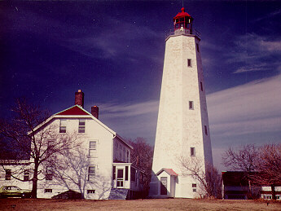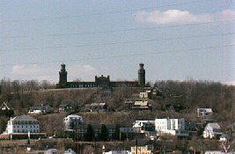
Sandy Hook Lighthouse Twin Lights, Navesink

Lesson Creators: Betty Clarke, Lori Stapleton, Susan Stratton and Kathleen Stricker,
Samsel Upper Elementary School, Sayreville
Grade level: 3-5
Timeframe: 4-5 class periods
Across the Curriculum Lessons about Lighthouses:
- History: Internet search and Timeline
- Geography: Location of lighthouses in NJ
- Math: Observations of height, color, shape (geometry)
- Science: How does an electric circuit work?, What is a fresnel lens?
- Language Arts: Read Beacons of Light Lighthouses and write an informative paragraph
- Art: Draw your own lighthouse or color a lighthouse (North American Lighthouses Coloring Book)
- Civics: Pennies for Preservation
Objectives:
Student will be able to explain why New Jersey has had so many lighthouses, the purpose of lighthouses and how the technology for ocean safety has changed.
NJ Core Content Social Studies Standards:
6.1.4.B.1 Compare and contrast information that can be found on different types of maps, and determine when the information may be useful.
6.1.4.B.4 Describe how landforms, climate and weather,…have impacted where and how people live and work
6.1.4.B.9 Relate advances in science and technology to environmental concerns, and to actions taken to address them.
6.1.4.C.14 Compare the different regions of NJ to determine the role that geography, resources, climate, transportation, technology…have played in economic opportunities.
6.1.4.C.15 Describe how the development of different transportation systems impacted he economies of New Jersey and the United States.

NJ Core Content Science Standards:

5.2 D Circuits: The conservation of energy can be demonstrated by keeping track of familiar forms of energy as they are transferred from one object to another.

Common Core Math Standards:

4.NBT.A.2 Read and write multi-digit whole numbers using base-ten numerals, number names, and expanded form.
4.NBT.B.4 Fluently add and subtract multi-digit whole numbers using the standard algorithm.
4.G.A.1 Draw points, lines, line segments, rays, angles (right, acute, obtuse), and perpendicular and parallel lines. Identify these in two-dimensional figures.
4.G.A.2 Classify two-dimensional figures based on the presence or absence of parallel or perpendicular lines, or the presence or absence of angles of a specified size. Recognize right triangles as a category, and identify right triangles.
4.G.A.3 Recognize a line of symmetry for a two-dimensional figure as a line across the figure such that the figure can be folded along the line into matching parts. Identify line-symmetric figures and draw lines of symmetry.
Common Core ELA Standards:
RI.4.1 Refer to details and examples in a text when explaining what the text says explicitly and when drawing inferences from the text.
RI.4.5 Describe the overall structure (e.g., chronology, comparison, cause/effect, problem/solution) of events, ideas, concepts, or information in a text or part of a text.
RI.4.7 Interpret information presented visually, orally, or quantitatively (e.g., in charts, graphs, diagrams, time lines, animations, or interactive elements on Web pages) and explain how the information contributes to an understanding of the text in which it appears.
RI.4.9 Integrate information from two texts on the same topic in order to write or speak about the subject knowledgeably.
SL.4.2 Paraphrase portions of a text read aloud or information presented in diverse media and formats, including visually, quantitatively, and orally.
SL.4.4 Report on a topic or text, tell a story, or recount an experience in an organized manner, using appropriate facts and relevant, descriptive details to support main ideas or themes; speak clearly at an understandable pace.
SL.4.5 Add audio recordings and visual displays to presentations when appropriate to enhance the development of main ideas or themes.
W.4.2 Write informative/explanatory texts to examine a topic and convey ideas and information clearly.
W.4.7 Conduct short research projects that build knowledge through investigation of different aspects of a topic.
Essential Questions
- What do lighthouses tell us about New Jersey’s geography and history?
- How has technology changed how lighthouses function?
Activities/Procedures:
Watch the video at http://www.youtube.com/watch?feature=player_embedded&v=c7TRiUhDdFg

What is a lighthouse?

Has anyone visited a lighthouse?

Where was the lighthouse?

Why are lighthouses located near the ocean?

What is their purpose?
Lighthouses served two primary purposes. The first was illuminating waterways made treacherous by shoals, reefs, rocks and other hazards as ships left the open ocean and pulled into port. Most lighthouses also include fog signals such as horns, bells or cannons, which sound to warn ships of hazards during periods of low visibility. The second purpose is to serve as a reference to mariners. An individual lighthouse distinguished itself with its day mark -- the color schemes and patterns on the tower -- and its light signature. For example, a lighthouse might emit two flashes every three seconds to distinguish it from a lighthouse that emits four flashes every three seconds.
- Reading: Children’s Literature connections.

Student read Beacons of Light: Lighthouses (Gail Gibbons). The author illustrates four famous lighthouses, explains how lighthouses help locate danger areas for ships, then provides a historical background about beacons of light from bonfires at the tops of hills to the bonfires in stone towers. Have students write an informative paragraph.

- Geography and History: Where are our lighthouses? Why does New Jersey have so many lighthouses? When were our lighthouses built?
- Look at the map of lighthouses around New Jersey (Handout 1).
- In groups, research the history of some or all of New Jersey’s lighthouses.

Jigsaw the information from each group and use the Lighthouse Timeline worksheet (Handout 2) to indicate when each lighthouse was constructed.

Which lighthouses are still functioning? Which are not? (Ambrose Light Tower, Brandywine Shoal Lighthouse, Cross Ledge Lighthouse, Elbow of Cross Ledge Lighthouse , Miah Maull Lighthouse, Ship John Shoal Lighthouse)
- Why do you think New Jersey has so many lighthouses?

- Lighthouse Math

- Using the chart on Handout 3, arrange the lighthouses in order of height, from the tallest to the shortest.
- Then, use their heights to calculate the number of steps in each lighthouse. (Hint: The Navesink Light has two towers. Do not forget to list both towers. Even though both towers have the same height, the North Tower has one more step.)
- Complete the chart (Handout 4) and discuss: Why do lighthouses need to be so tall?
- History: Sandy Hook, New Jersey’s first lighthouse and the oldest lighthouse in continuous use the country
New Jersey is home to the oldest U.S. lighthouse (Sandy Hook) and several other very historic light stations (lighthouses are also referred to as “lights”). As early as 1679-80, Edmund Andreas, Colonial Governor of the Colony of New York, suggested to Sir George Carteret the advisability of constructing a lighthouse on Sandy Hook. However, no action was taken until 1761, when the project was revived by the merchant community of New York City, which has lost significant sums due to shipwrecks. The Provincial Council of the Colony of New York approved the purchase of land and the construction of a lighthouse from the proceeds of two lotteries. The lighthouse was completed in 1764 and is celebrating its 250th anniversary in 2014.
Sandy Hook Lighthouse was built of granite known as “rubblestone,” about 500 feet from the tip of the hook. Today, due to the northward expansion of the hook it now stands about 1 ½ miles from the point. The lamps installed in the crown were of copper encased in a lantern of ordinary glass. The keeper lived in a stone dwelling beside the tower. In order to pay for the upkeep of the lighthouse, a duty of three-pence per ton was imposed on shipping using the channel into New York Harbor.
In early 1776, the American colonists destroyed the light to avoid aiding the British fleet that was shortly expected to appear off New York City, prior to the invasion of the city. A British landing party relit the tower using improvised lamps and reflectors. On June 1, 1776, the Americans again tried to extinguish the light, this time using a pair of cannons mounted on several small boats. The Americans succeeded in damaging the tower somewhat before being driven off by an approaching armed vessel.
The Sandy Hook lighthouse became the first lighthouse in the country to be lit by electric incandescent lamps in 1889.
On June 11, 1964, Sandy Hook Lighthouse was declared an official National Historic Landmark, on the 200th anniversary of the date it began operation. The lighthouse and surrounding Fort Hancock are part of Gateway National Recreation Area today. The lighthouse is still in active operation. It is visible 19 miles at sea. In 1996, the ownership of the lighthouse was transferred from the Coast Guard to the National Park Service.
After reading about the history of Sandy Hook Lighthouse, answer the following questions:
- Why was Sandy Hook Lighthouse built?
- How was it maintained?
- Why was the lighthouse important during the American Revolution?
- Why is the Sandy Hook lighthouse now situated 500 feet from the tip of the hook?
- Critical Thinking: Solve the Mystery of the Twin Lights
In the 1820s, because the volume of ships entering and departing the port of New York had become enormous, the federal government acquired just over two acres of land on the shores of the Navesink River for a new lighthouse. In 1828 the Federal Government built two identical, unconnected towers known as “twin lights." But, after just 10 years, an 1838 report described the poor condition of the station: “the beams under the floors rotten; tower leaks in many placed; the light shows badly towards the north. Keeper's dwelling in good repair.”
By 1862, the lighthouses were in such a state of disrepair that the government decided to replace the structures with two new light towers connected by storage galleries and keepers quarters. The station became a showcase for the Lighthouse Establishment, where new navigational technology was tested before being employed in widespread use at other stations. Twin Lights became the initial first-order light to be fueled by mineral oil (kerosene) in 1883, and the first electrically powered lighthouse in 1898, when a huge bi-valve lens was installed in the south tower illuminated by an electric arc lamp. At that time, the south tower became the most powerful lighthouse in the country, producing a light of 25,000,000 candle-power that could be seen 22 miles at sea, though there were reports of it having been seen as far away as 70 miles when the light was reflected off a low lying cloud bank. The light-station was used until it was decommissioned by the Coast Guard in 1949. Highly sophisticated aids to navigation, including the Ambrose Light-tower, made Twin Lights unnecessary. The huge bivalve lens was acquired by the Boston Museum of Science and Technology from the Coast Guard in 1951, and placed on exhibit there.
In 1960, the facility became a New Jersey State Historic site. In 1979, through the efforts of the Twin Lights Historical Society, Rumson Garden Club, and NJ Division of Parks and Forestry, the Fresnel lens was returned home to Twin Lights. Today, the museum features well-interpreted exhibits of lighthouse, Life-Saving Service and other memorabilia. For more information call, (732) 872-1814 or contact the New Jersey Lighthouse Society at http://www.njlhs.org/njlight/njlights.html
The location of the initial twin lights had been lost. Their location and why they fell into disrepair so quickly were mysteries to be solved by archeological excavation. Can you help solve the mystery?
Have students complete the Twin Lights Word Find (Handout 4) Then explain that the original twin Lights were built of rubble and with beach sand used as mortar to hold it together. The salt in beach sand leads to rapid mortar failure, causing the structure to quickly fall apart. A team of archeologists and students from Monmouth University discovered this when excavating for the original twin lights. (See Digging New Jersey’s Past: Historical Archeology in the Garden State by Rich Veit (2002).

Science: How do the lights in lighthouses work?

Early lighthouses were lit by candles, coal fires, and oil lamps, then coal gas, Electricity was used for the first time in the 1850s and most lighthouses today use electricity.

How does an electrical circuit work?

Electricity follows a closed path called a circuit. The electricity flows around and around. Circuits need something to act as the source of electricity. When you put a battery in the circuit, electricity can flow. There is usually a switch in the circuit that lets you stop the flow of electricity when needed. When the circuit is closed, electricity will flow all through the circuit. When the switch is open, you create a hole in the circuit, and the flow of electricity stops.

Students read “What is an Electrical Circuit” (Handout 5) and answer the true/false questions and label the parts of the closed circuit.

What is a Fresnel Lens?

The Fresnel lens is used to focus the light beam. A Fresnel lens can capture more oblique light from a light source, thus allowing the light from a lighthouse equipped with one to be visible over greater distances Imagine taking a plastic magnifying glass lens and slicing it into a hundred concentric rings (like the rings of a tree). Each ring is slightly thinner than the next and focuses the light toward the center. Now take each ring, modify it so that it's flat on one side, and make it the same thickness as the others. To retain the rings' ability to focus the light toward the center, the angle of each ring's angled face will be different. Now if you stack all the rings back together, you have a Fresnel lens. Large Fresnel lenses are often used as solar concentrators. The first Fresnel lens (named after its French inventor, Augustin-Jean Frensel) was used in 1823 in a lighthouse in France.

Have students look at Handout 6 and explain how a Fresnel light works.

A Fresnel lens was installed in Sandy Hook Lighthouse in 1857. The light at Sandy Hook Lighthouse throws a light 12 miles out to sea. Not all lighthouses have Fresnel lenses. What other New Jersey lighthouse has a Fresnel lens? Navesink Twin Lights

Changes in technology:

What other technology do we have today to avoid shipwrecks? Radar, sonar, two-way radios, and emergency locators. But the lights from lighthouses are still used and helpful.
- Art (and maybe even some Math): Create your own lighthouse

Have students construct models of lighthouses from paper, using math skills to measure the angles. Alternatively, have students draw a lighthouse or color a lighthouse (North American Lighthouses Coloring Book)

Assessment
Students write a short essay explaining what lighthouses tell us about New Jersey’s geography and history and how technology has changed the function of preventing shipwrecks.

Extension
- Civics: Pennies for Lighthouse Preservation.

The maintenance of these national treasures that protect our coastline rely heavily on the donations from the public. Have your students solicit contributions for the upkeep of the state’s lighthouses. Donations for the maintenance of New Jersey’s historic lighthouses can be sent to: New Jersey Lighthouse Society, P.O. Box 332, Navesink, NJ 07752-0332.

- Take the Lighthouse Challenge.

The “Lighthouse Challenge of New Jersey” is held the third weekend of October each year. The challenge is to visit as many lighthouses as possible and to help raise needed funds for the continued preservation of our treasured landmarks. Go to http://www.lighthousechallengenj.org/
- History: The Statue of Liberty was a lighthouse?
A gift of friendship from the people of France to the United States and is recognized as a universal symbol of freedom and democracy, the Statue of Liberty was dedicated on October 28, 1886. Everyone is familiar with the Statue of Liberty as a symbol of the promise of America, but few are probably aware that, for a few years early in its existence, it was also officially a lighthouse operated under the authority of the Lighthouse Board. The lighted torch in Lady Liberty’s right hand had, and still has, great symbolic significance, but at its beginning, it was also used as a navigational aid for ships entering New York Harbor. In 1886, President Grover Cleveland ordered that the Statue of Liberty be “henceforth maintained, lighted and tended in accordance with such rules and regulations as now exist” under the Lighthouse Board. The Lighthouse Board experimented with electric arc lamps placed in the torch of the Statue of Liberty, which was used briefly during this time as an aid to navigation.
Have students look at Handout 7 of the Statue of Liberty to consider it as a lighthouse and find out more about the Statute of Liberty as a lighthouse by going to http://www.lighthousefriends.com/light.asp?ID=581
- Invite a speaker from the NJ Lighthouse Historical Society to speak to visit your school and speak with your students about our state's lighthouses.

Field trip. Visit a Lighthouse near you. Those open to the public include the following (click on them for more information):

Barnegat Lighthouse

Cape May Lighthouse

East Point Lighthouse

Finn's Point Range Light

Hereford Inlet Lighthouse

Tucker's Island Lighthouse(Replica)

Navesink Twin Lights

Sandy Hook Lighthouse

Sea Girt Lighthouse

Statue of Liberty

Tinicum Island Range Light

Handout 1

New Jersey Lighthouse Map

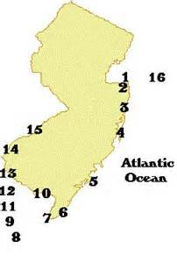
- Sandy Hook Lighthouse 9. Miah Maull Lighthouse
- Twin Lights of Navesink 10. East Point Lighthouse
- Sea Girt Lighthouse 11. Cross Ledge Lighthouse
- Barnegat Lighthouse 12. Elbow of Cross Ledge Lighthouse
- Absecon Lighthouse 13. Ship John Shoal Lighthouse
- Hereford Inlet Lighthouse 14. Finns Point Range Light
- Cape May Lighthouse 15. Tinicum Range Light
- Brandywine Shoal Lighthouse 16. Ambrose Light Tower

Handout 2
Name Homeroom
New Jersey’s Lighthouses
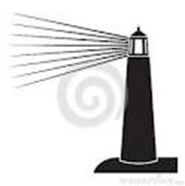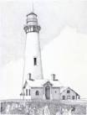

1820 1830 1840 1850 1860 1870 1880 1890 1900
Handout 3

Handout 3

New Jersey's Lighthouses

Use the data below to complete this assignment. First, arrange the lighthouses in order of height, from the tallest to the shortest. Next, use their heights to calculate the number of steps in each lighthouse. (Hint: The Navesink Light has two towers. Do not forget to list both towers. Even though both towers have the same height, the North Tower has one more step.)

Lighthouse Names and Heights
*********************************************************************************************************************

Hereford Inlet 57 ft. Absecon 169ft.
Finn's Pt. Rear Range 115 ft. Tinicum Rear Range 112ft. East Point 40ft. Cape May 157ft.
Sandy Hook 85 ft.
Barnegat 165 ft. Sea Girt 44 ft.

Navesink Twin Lights North Tower 73 ft. Navesink Twin Lights South Tower 73 ft.
********************************************************************************************************************

Number of Steps

217 steps

45 steps
95 steps

199 steps
112 steps

228 steps

64 steps
65 steps

59 steps
119 steps

51 steps

************************************************************************************************************

Lighthouse Name Height in Feet
Number of Steps

************************************************************************************************************

________________________________ __________________ __________________

________________________________ _________________ __________________

If all of the lighthouses were placed one on top of each other, how many feet high

would they be?

If you climbed to the top of all of these lighthouses, how many steps would you have climbed?

Handout 4
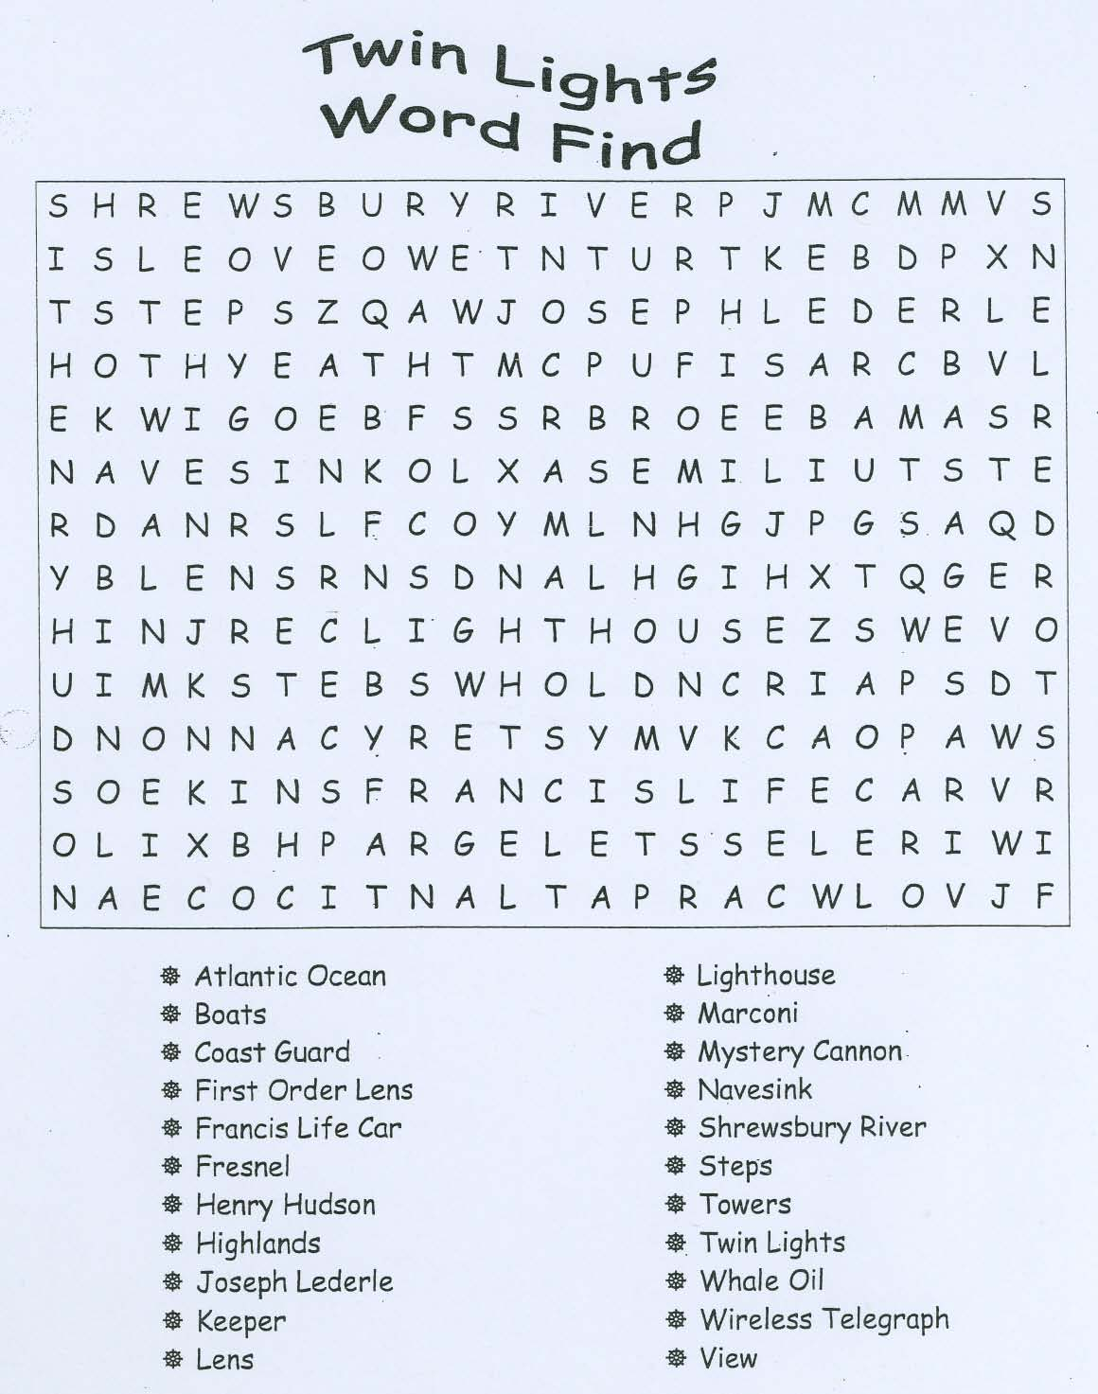

Handout 5
Name:___________________________________ Date:______________________
Period:_______________ Homeroom:_________________
What is an Electric Circuit?

Electricity follows a closed path called a circuit. The electricity flows around and around. Circuits need something to act as the source of electricity. When you put a battery in the circuit, electricity can flow. There is usually a switch in the circuit that lets you stop the flow of electricity when needed. When the circuit is closed, electricity will flow all through the circuit. When the switch is open, you create a hole in the circuit, and the flow of electricity stops.
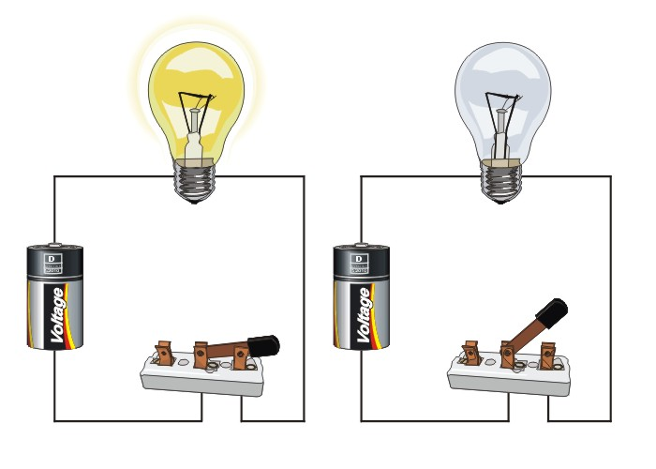
Closed Circuit Open Circuit

Read each statement: Write “T” if the statement is true of “F” if it is false.

- _____ In order for electricity to work, it must be able to leave a battery and return to a battery.

- _____ The path electricity takes is called a circuit.
- _____ If a switch is open, it is a closed circuit.
- _____ Batteries can supply the source of electricity in a circuit.
- _____ Electricity does not flow in a closed circuit.
- _____ Wires are used to connect the parts of a circuit together.
- Label the following parts of the closed circuit on the lines provided:

Battery Switch Light bulb

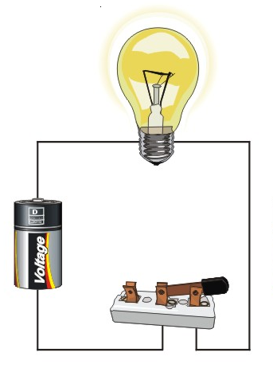

Handout 6
Fresnel Lens
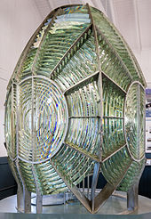
Fresnel lens on display at Point Arena Lighthouse Museum, Mendocino, CA

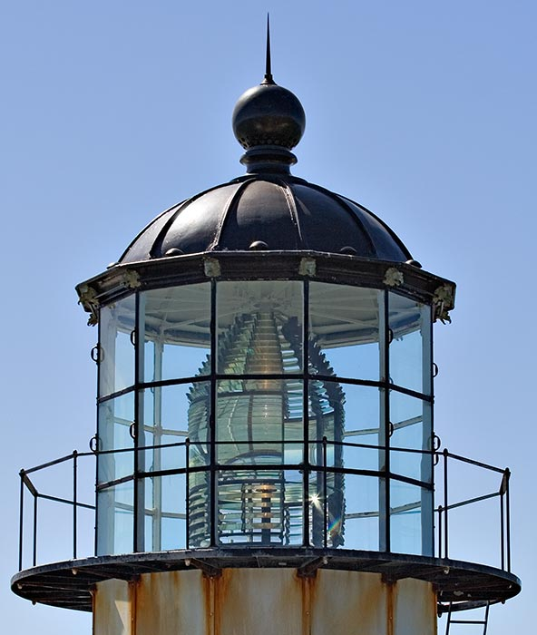
Fresnel Lens in a lighthouse
Handout 7
Find out more about the Statute of Liberty as a lighthouse by going to http://www.lighthousefriends.com/light.asp?ID=581
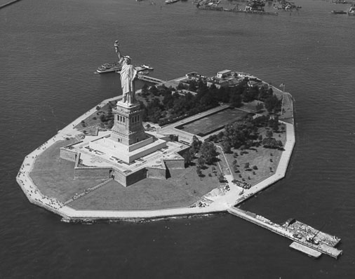
The Statue of Liberty

