Innovations from New Jersey
Creator: NJ Center for Civic Education, Rutgers, The State University of New Jersey

This series of lessons may be taught as part of a week-long unit on Immigration or the individual lessons and activities might be integrated as part of U.S. History from 1840 to today.

Table of Contents
Page 3: Alexander Hamilton and Great Falls
Page 6: John Stevens, Steam engines and Interstate Commerce
Page 9: Alfred Vail and the telegraph
Page 10: Thomas Edison, patents and the communications revolution
Page 16: Food and New Jersey
Page 18: Selman Waksman and the development of antibiotics
Page 19: Bell Labs and the start of the electronic and internet revolution

Objectives: Student will be able to:
- Explain the scientific method and how it was used by New Jersey inventors
- Define what makes an entrepreneur and identify New Jersey inventors that fit this definition
- Explain how inventions from New Jersey ushered in the market revolution of the 1820s-60s with John Steven’s steam transportation
- Determine how Thomas Edison’s inventions pushed a revolution in communications at the turn of the 19th century
- Describe how Dr. Waksman developed streptomycin and its impact on to deadly diseases such as tuberculosis in the 1950s
- Analyze the beginnings of the computer age with Bell Lab’s transistor, laser, information theory, UNIX operating system and programming languages in the1970s and 80s
- Determine how innovations from New Jersey have improved society

Questions:
- Why were the Great Falls in Paterson, NJ selected as the site for the first industrial city in the country?
- What new areas of the economy did the invention of the light bulb, the phonograph, the automobile and the motion picture open?
- How have these inventions contributed to the improvement of our lives?
- How has the electronics and internet revolution changed the way we live?
- Why do you think that many of these inventions were initially developed in New Jersey?
- How can we balance the need for economic development with preservation of the environment and a life style free from unhealthy contaminants?

NJ Social Studies Standards:

6.1.12.C.3.a Analyze how technological developments transformed the economy, created international markets, and affected the environment in New Jersey and the nation
6.1.12.D.5.a Analyze government policies and other factors that promoted innovation, entrepreneurship, and industrialization in New Jersey and the United States during this period
6.1.12.C.8.b Relate social, cultural, and technological changes in the interwar period to the rise of a consumer economy and the changing role and status of women.
6.1.12.C.14.d Relate the changing manufacturing, service, science, and technology industries and educational opportunities to the economy and social dynamics in New Jersey.
6.1.12.A.16.a Examine the impact of media and technology on political and social issues in a global society
6.1.12.A.16.b Analyze government efforts to address intellectual property rights, personal privacy, and other ethical issues in science, medicine, and business that arise from the global use of new technologies.
6.1.12.A.16.c Assess from various perspectives the effectiveness with which the United States government addresses economic issues that affect individuals, business, and/or other countries.
6.1.12.C.16.a Evaluate the economic, political, and social impact of new and emerging technologies on individuals and nations

Common Core ELA Standards:

RH.11-12.1: Cite specific textual evidence to support analysis of primary and secondary sources, connecting insights gained from specific details to an understanding of the text as a whole.
RH.11-12.2: Determine the central ideas or information of a primary or secondary source; provide an accurate summary that makes clear the relationships among the key details and ideas.
RH.11-12.3: Evaluate various explanations for actions or events and determine which explanation best accords with textual evidence, acknowledging where the text leaves matters uncertain.
RH.11-12.4: Determine the meaning of words and phrases as they are used in a text, including analyzing how an author uses and refines the meaning of a key term over the course of a text (e.g., how Madison defines faction in Federalist No. 10).
RH.11-12.5: Analyze in detail how a complex primary source is structured, including how key sentences, paragraphs, and larger portions of the text contribute to the whole.
RH.11-12.6: Evaluate authors' differing points of view on the same historical event or issue by assessing the authors' claims, reasoning, and evidence.
RH.11-12.7: Integrate and evaluate multiple sources of information presented in diverse formats and media (e.g., visually, quantitatively, as well as in words) in order to address a question or solve a problem.
RH.11-12.8: Evaluate an author's premises, claims, and evidence by corroborating or challenging them with other information.
RH.11-12.9: Integrate information from diverse sources, both primary and secondary, into a coherent understanding of an idea or event, noting discrepancies among sources.

More than half a dozen innovations from New Jersey have dramatically improved lives and spurred economic revolutions in transportation, food, medicine, and communication. The six lessons below may be incorporated individually as time periods from the 1790s to today are explored or they may be used together as a unit on innovation, invention and entrepreneurship.

Anticipatory set: Ask students: What is an “innovation”? Discuss student responses and make sure that students understand that an innovation is a new idea, or more-effective device or process. An innovation may be the application of better solutions that meet new requirements, unarticulated needs, or existing market needs. Then ask, what is an “invention”? Again, discuss student responses and make clear that an invention may be an improvement upon a machine or product, or a new process for creating an object or a result. Ask, what is the difference between and invention and an innovation? To be called an invention, an idea only needs to be proven as workable. But to be called an innovation, it must also be replicable at an economical cost, and must satisfy a specific need. That's why only a few inventions lead to innovations because not all of them are economically feasible. An inventor develops a new good or service, but does not necessarily bring it to market. An entrepreneur risks resources (natural, human and capital) to bring a new or improved product or service to market. The entrepreneur may not have invented the product or service. Profit is the incentive for the entrepreneur. As an introductory activity, go to the lesson on Econedlink by the Council for Economic Education at http://www.econedlink.org/lesson/380/Improving-Original to understand the difference between innovations, inventions, and entrepreneurs.
- Alexander Hamilton and Great Falls, Paterson, NJ—the first industrial park

Background: Teacher presentation or lecture or student handout or reading. Recognizing the need to spur economic development, the founders included in the U.S. Constitution a provision authorizing Congress “to promote the Progress of Science and useful Arts, by securing for limited Times to Authors and Inventors the exclusive Right to their respective Writing and Discoveries” (Art. I, Sec. 8, para. 8), that is, patents and copyrights. The United States Patent Office considers an invention patentable only if the invention is novel; not obvious; and has utility. Over 6 million patents have been issued since the first patent in 1790

At the start of the republic, the new nation was an agricultural society, importing most of its needed manufactured goods from Britain. As President Washington’s Treasury Secretary, Alexander Hamilton had a vision to secure the economic foundation of the United States that included the federal assumption of state debts, the creation of the Bank of the United States and support from the government to encourage the growth of manufacturing. The first Congress approved the assumption of state debts from the Revolution by the federal government in the Funding Act of 1790. It also approved legislation to create the First Bank of the United States in 1791, which was built in Philadelphia while it was still the nation’s capital. In December 1791, Hamilton presented to Congress a Report on the Subject of Manufacturers, which recommended high tariffs to protect American industry from competition, government subsidies for “new inventions…particularly those which relate to machinery” and internal improvements. Congress, however, was not as enthusiastic. The report was never put up to a vote.

See video on Alexander Hamilton and New Jersey at https://www.youtube.com/watch?v=YL4hkHAa85o.
In the meantime, however, Hamilton and his former Treasury Department assistant, William Duer, founded the "Society for the Establishment of Useful Manufactures." Supported by private investors, the society was chartered by New Jersey under Hamilton's direction to exploit the falls for this planned city, which Hamilton called a "national manufactory". The enterprise was a public-private partnership: it was exempt from property taxes for ten years. The society founded the city of Paterson in the vicinity of the falls, naming it in honor of William Paterson, the governor of New Jersey. Hamilton commissioned civil engineer Pierre Charles L'Enfant, responsible for the layout of the new capital at Washington, D.C. to design the system of canals known as raceways supplying the power for the watermills in the new town. His magnificent and impracticable ideas were soon abandoned but a series of raceways were constructed.

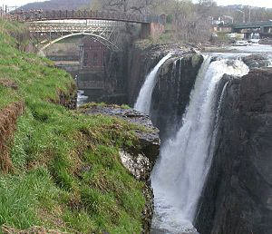
The Great Falls of the Passaic River,
Showing the turbine housing of the S.U.M. dating from 1911

The Great Falls of the Passaic River in Passaic, New Jersey became America’s first planned industrial city in 1791. The water falls were harnessed as a power source for grist mills and resulted in the growth of Paterson as one of the first industrial centers in the United States. Hamilton hoped to demonstrate the ability of the United States make proper use of its plentiful raw materials and its people's special aptitude for technological pursuits through successfully manufacturing. Although the Society was dissolved after only five years because it was losing money, it was the first manufacturing corporation chartered by the state of New Jersey and established a model for the future. Later on, the management of the falls became a lucrative source of profits as the area became the nucleus for a growing mill industry. By 1815, thirteen water-powered cotton mills were operating beside the falls, operated by over 2,000 workers. As a result of the society's success in promoting industry, the population of Paterson grew from 500 in the 1790s to over 5,000 by 1820. By the 1830s, the textile mill industry in the area had been surpassed by larger and better-capitalized steam-powered operations in New England and the local mill industry shifted toward the manufacture of steel and locomotives. The Rogers Locomotive and Machine Works, which began operating in 1832, was the first such success. By the time of the American Civil War, the milling of steel and the manufacture of locomotives had become the dominant industry. In the 1880s, the area became the center of the nation's silk industry. The society continued operations into the 20th century but fell into decline with the abandonment of the area by industry. In 1945, the society's charter and property were acquired by the city of Paterson. But American industry started here.

Critical thinking activity: Ask students to look at a map of the eastern United States and explain why Hamilton selected the Great Falls as the site for the first United States industrial park. Hamilton had visited the Great Falls of the Passaic River in 1778 when he was serving as an aide to General Washington during the American Revolution and saw how powerful they were. The energy of the waterfalls was harnessed as a power source for raw products (cotton, iron, silk) that could be manufactured into finished products. The falls were not only powerful but also conveniently located within the main population centers of the country between New York City and Philadelphia and on a river which could be reached from New York Harbor. In addition to being located near the nation’s population centers, land in New Jersey was cheap and there were abundant forests and rivers.

Why did New Jersey fit the criteria of a manufacturing location described by Alexander Hamilton in his Report on Manufacturers? Why did railroads come to New Jersey? Go to the NJ Digital Highway at http://www.njdigitalhighway.org/enj/lessons/thomas_edison/?part=growth_of_industry
for an activity to help answer this question.

Critical thinking activity: Ask students: What governmental support did the Society for the Establishment of Useful Manufactures (SUM) have from government? It was exempt from local property taxes for ten years. Do you think that the federal /state or local government should be supporting economic development or should it be left to private individuals? How do you think government should support economic development?

- John Stevens, Steam engines and Interstate Commerce
Industrial development in the early 19th century would not have been possible without steam engines. In 1781 Scottish engineer James Watt patented a steam engine that produced continuous rotary motion. Watt's ten-horsepower engines enabled a wide range of manufacturing machinery to be powered. The engines could be sited anywhere that water and coal or wood fuel could be obtained. With steam engines, it was possible to construct mainline railways, which were a key component of the industrial revolution. Railways reduced the costs of shipping, and allowed for fewer lost goods, compared with shipping over water, which faced occasional sinking of ships. The change from canals to railways allowed for "national markets" in which prices varied very little from city to city. Watt’s steam engine also enabled a wide range of manufacturing machinery to be powered since the engines could be placed anywhere that water and coal or wood fuel was available.

Steam engines were also being used to power ships and for manufacturing. John Stevens was a lawyer, engineer and inventor in Hoboken, NJ, who constructed the first U.S. steam locomotive, the first steam-powered ferry and the first U.S. commercial ferry service. In 1791, Stevens received one of the first three patents issued by the United States Patent Office, all three of which were applications of steam power. In 1809, Steven’s steamship, Phoenix, left Hoboken on a trip down the Atlantic Ocean along the coastline of New Jersey and then up the Delaware River to Philadelphia. It was the first steamship to make an ocean voyage. In 1811, Steven’s steam ferry, Juliana, was the first to run across the Hudson River between New York and Hoboken. The first railroad charter in the U.S. was given to Stevens and others in 1815 for the New Jersey Railroad. He designed and built a steam locomotive capable of hauling several passenger cars at his estate in Hoboken, New Jersey in 1825.

Procedures/Comparing Inventors Activity: John Stevens (1749-1838) and James Watt (1736-1819) were both interested in developing the use of steam engines. Have students conduct research (or use the information provided below) and complete Handout 1: Graphic Organizer comparing John Steven and James Watt or prepare a short essay comparing their backgrounds and accomplishments. Essays should note the similarities: both came from prominent families had excellent educational backgrounds and were curious tinkerers, their inventions were practical and had enormous impact on the improvement of transportation during the early 19th century, and institutions of higher learning were established in their names. Students should use the graphic organizer, Handout 1, to help them organize their comparison of the two inventors.

- James Watt was born in a Scottish seaport on the Firth of Clyde in 1736. His father was a shipwright, ship owner and contractor, and served as a civic officer for the town. His mother came from a distinguished family and was well educated. When he was eighteen, his mother died and his father's health began to fail. Watt travelled to London to study instrument-making for a year, then returned to Scotland, settling in the major commercial city of Glasglow intent on setting up his own instrument-making business. Although steam engines had been in use for more than 50 years, they weren’t very workable. In 1765, Watt realized that too much heat was being lost in the process and developed a model of a more efficient steam engine that provided more steam to perform work. Watt had a working model later that same year and a patent for it by 1781. Watt Memorial Library was begun in 1816 with Watt's donation of scientific books, and developed as part of the Watt Institution by his son, which ultimately became the James Watt College, now part of West College Scotland.

- John Stevens was born in Perth Amboy, New Jersey. His father was a prominent state politician who served as a delegate to the Continental Congress, and his mother, Elizabeth Alexander, was the daughter of New York lawyer and statesman. Stevens graduated King's College (now Columbia University) in 1768. At age 27 he was appointed a captain in Washington's army, and was afterwards treasurer of New Jersey. In 1784, he bought land that had been confiscated from a Tory (Loyalist) landowner at a public auction from the state of New Jersey. His land purchase comprised approximately what is now the city of Hoboken. Stevens was a lawyer, engineer and inventor. He constructed the first U.S. steam locomotive, the first steam-powered ferry, the Phoenix in 1806, which was the first steamship to successfully navigate open ocean to Philadelphia, and first U.S. commercial ferry service from in 1811 from Hoboken, NJ to New York City, NY. He obtained the first railroad charter in 1815 and designed and built a steam locomotive capable of hauling several passenger cars in 1825. He also helped to develop U.S. patent law. Stevens built an estate at Castle Point in Hoboken, on land that was given by his son to create Stevens Institute of Technology in 1870.

John Stevens and James Watt

 | James Watt | John Stevens
Birth date and place | Island of Firth, Scotland  1736 | Perth Amboy, NJ  1745
Families | Father a civic leader  Mother from a distinguished family and well-educated | Father a prominent statesman  Mother from a distinguished family
Eduational Background | Well educated | Graduated from a prestigious university
Accomplishments | Developed and patented in 1781 a workable steam engine | Constructed the first U.S. steam locomotive, and the first steam-powered ferry, the Phoenix in 1806, , and the first U.S. commercial ferry service from in 1811 from Hoboken, NJ to New York City, NY.  Obtained the first railroad charter in 1815 and designed and built a steam locomotive capable of hauling several passenger cars in 1825.  Helped to develop U.S. patent law.
Legacies | Watt Memorial Library, now part of West College in Scotland | Stevens Institute of Technology in Hoboken, NJ
Other information

The Law and the entrepreneur: Gibbons v. Ogden (1824): The case that defined the scope of interstate commerce.
It was the operation of steamboats on the Hudson River between New Jersey and New York that prompted the U.S. Supreme Court decision that made it clear that the federal government had the right to regulate interstate commerce. A New York state law gave to individuals the exclusive right to operate steamboats on waters within state jurisdiction. Laws like this one were duplicated elsewhere which led to friction as some states would require foreign (out-of-state) boats to pay substantial fees for navigation privileges. In this case Thomas Gibbons -- a steamboat owner who did business between New York and New Jersey under a federal coastal license -- challenged the monopoly license granted by New York to Aaron Ogden. New York courts consistently upheld the state monopoly.

On appeal to the U.S. Supreme Court under Art III, Section 2 granting the federal courts jurisdiction over cases arising “between Citizens of different States,” the question was: Did the State of New York exercise authority in a realm reserved exclusively to Congress, namely, the regulation of interstate commerce?

The unanimous Court found that New York's licensing requirement for out-of-state operators was inconsistent with a congressional act regulating the coasting trade (Act of February 1793, Sec. 1, Clause 8). The New York law was invalid by virtue of the Supremacy Clause U.S. Constitution, Art. I, Sec. 8, Clause 3: granting Congress the power “to regulate Commerce with foreign Nations, and among the several States, and with the Indian tribes”. In his opinion, Chief Justice John Marshall developed a clear definition of the word commerce, which included navigation on interstate waterways. He also gave meaning to the phrase "among the several states" in the Commerce Clause. Marshall's was one of the earliest and most influential opinions concerning this important clause. He concluded that regulation of navigation by steamboat operators and others for purposes of conducting interstate commerce was a power reserved to and exercised by the Congress.

Close Reading Activity: Have students read Handout 2: Gibbons v. Ogden (1824). Have them identify and define any words that they do not understand. Students answer the following questions:
- How does the U.S. Supreme Court define “commerce”?
- How does it define “among the several States”?
- Why does the Court conclude that the New York law must give way to federal law?
- Why was this decision important to the development of commerce in the United States?
- Why was this decision important to the development of the power of the federal government?

Gibbons v. Ogden set the stage for future expansion of congressional power over commercial activity and a vast range of other activities once thought to come within the jurisdiction of the states. After Gibbons v. Ogden, Congress had preemptive authority over the states to regulate any aspect of commerce crossing state lines. Thus, any state law regulating in-state commercial activities (e.g., workers' minimum wages in an in-state factory) could potentially be overturned by Congress if that activity was somehow connected to interstate commerce (e.g., that factory's goods were sold across state lines). Indeed, more than any other case, Gibbons v. Ogden set the stage for the federal government's overwhelming growth in power into the 20th century. All started by a dispute between ferry boat transportation across the Hudson River between New Jersey and New York.

- Alfred Vail and the Telegraph

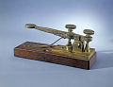
Telegraph Key created by Alfred Vail, 1844,
Artifact, National Museum of American History, EM*181411.

Provide background: Born in 1807 in Morristown, New Jersey, Alfred Vail’s father owned the Speedwell Iron Works. Situated at a natural gorge of the Whippany River, several hydraulic powered forges predated the establishment of the ironworks. In 1815, Vail became sole owner of the Speedwell works and expanded it, producing a variety of agricultural and industrial machinery. After completing public school, Alfred Vail worked as a machinist at the iron works. The engine for the SS Savannah, the first steamship to cross the Atlantic Ocean, was built at the Speedwell Ironworks in 1818. In 1832, he began coursework in theological studies at the University of the City of New York, now New York University, with the hope of becoming a Presbyterian minister.

Samuel Morse was born in Charlestown, Mass. in 1791. He was a professional artist, not a scientist. He graduated from Yale in 1810 and lived in England from 1811 to 1815, where he exhibited at the Royal Academy in 1813. He spent the next ten years as an itinerant artist with a particular interest in portraiture. He returned to America in 1832 and became a professor of painting and sculpture at the University of the City of New York. Hearing a discussion on electromagnets gave him the idea for an electric telegraph and he gave the development of a telegraph his full attention. In 1837 Vail saw Morse demonstrate an early version of his electric telegraph in New York, and convinced Morse to take him on as a partner. The contract between the two stated that Vail—for a share of interest in Morse’s rights to the telegraph—would work on constructing the telegraph machines and financing the American and foreign patents. During his work on the telegraph, Morse needed political help to obtain support from Congress as much as he required technical and financial assistance, and he also shared ownership in a future telegraph system with Congressman Francis Ormond Jonathan "Fog" Smith (four shares).

Vail vastly improved Morse’s original design of the machine. Instead of using pendulums, Vail added weights to the machine’s turning key. He also substituted a steel pointed pen for the pencil Morse had employed, to indent the code into the paper tape the machine used and improved the mechanics of the register, the instrument that punched out the code via electric impulse, as well. Additionally, Vail developed a simpler alphabetic system of code to replace Morse’s original, but more complicated numerical code, in which dashes and dots were interpreted as numbers and then translated into words in a code book. Vail’s alpha code greatly sped up the process of deciphering messages. Though his contributions to the project were extremely significant, it was Morse’s name that appeared on the patents. Consequently, Morse is remembered, and Vail is often not.

Samuel Morse and Alfred Vail sent the first telegram using Morse code, and the first in America, on January 11, 1838 in Morristown, New Jersey from the Speedwell Ironworks. It was the beginning of a revolution in communications, as soon there were lines linking all the major cities on the East Coast. By 1861, the telegraph connected the West Coast to the East Coast, bringing an end to the Pony Express.
With changing industrial trends and a decline in the flow of the Whippany River, the ironworks were shut down in 1873, and its equipment sold. The remains of the factory buildings burned in 1908, and the few surviving walls and foundations remain unrestored. Speedwell Village was declared a National Historic Landmark in 1974.
Go to the video about the Invention of the Telegraph at https://www.youtube.com/watch?list=PLU0OVRbhFK0rDPCDQI42aPb_5MpGikfNG&v=RNhinA8ajoI.
You decide: Both Vail and Morse left their papers to the Library of Congress, including their contract. Based on their contract which can be found at https://www.loc.gov/collections/samuel-morse-papers/articles-and-essays/collection-highlights/invention-of-the-telegraph/, do you think it was fair for Morse to patent the telegraph solely in his name? Why or why not?
- Thomas Edison, patents and the communications revolution
Although protecting authors and inventors with limited monopolies was not without precedent, few countries have enshrined this concept in their founding document. The United States Constitution included a specific provision for Congress to “promote the Progress of Science and useful Arts, by securing for limited Times to Authors and Inventors the exclusive Right to their respective Writing and Discoveries” (U.S. Constitution Art. 1, Sec. 8, para. 8, 1787 ratified 1788), which was done through the passage of the Patent Act of 1790 and successive patent acts.
We associate the invention of the lightbulb with Thomas Edison in Menlo Park, New Jersey, but we often forget that Edison was the author of many other important inventions, including the idea of a research lab. Edison called his research lab his “invention factory.” In fact, Edison did not “invent” the light bulb. Arc lighting, which was bright enough to light a street but too bright for inside, had been invented prior to Edison. What he did invent was the incandescent bulb in 1879 which was soft enough for inside use and burned long enough to light a home for many hours. Then Edison and his lab assistants invented the electric power system, including wires, fuses and switches, to bring electricity to homes and businesses.
Background: Thomas Alva Edison was born on February 11, 1847, in Milan, Ohio. He was the last of the seven children of Samuel and Nancy Edison. Thomas's father was an exiled political activist from Canada. His mother was a school teacher and a major influence in Thomas’ early life. In 1854, the family moved to Port Huron, Michigan, where Edison attended public school for a total of 12 weeks. A hyperactive child, prone to distraction, he was deemed "difficult" by his teacher. His mother quickly pulled him from school and taught him at home. At age 11, he showed a voracious appetite for knowledge, reading books on a wide range of subjects. In this wide-open curriculum Edison developed a process for self-education and learning independently that would serve him throughout his life.

At age 12, Edison began to sell newspapers to passengers along the Grand Trunk Railroad line. Exploiting his access to the news bulletins teletyped to the station office each day, Edison began publishing his own small newspaper, called the Grand Trunk Herald. The up-to-date articles were a hit with passengers. This was the first of what would become a long string of entrepreneurial ventures where he saw a need and took the opportunity to capitalize on it. While he worked for the railroad, a near-tragic event turned fortuitous for the young man. After Edison saved a 3-year-old from being run over by an errant train, the child’s grateful father rewarded him by teaching him to operate a telegraph. By age 15, he had learned enough to be employed as a telegraph operator. For the next five years, Edison traveled throughout the Midwest as an itinerant telegrapher, subbing for those who had gone to the Civil War. He read widely, studied and experimented with telegraph technology, and became familiar with electrical science. In 1868, Edison ventured to Boston, landing a job with the Western Union Telegraph Company. In his spare time, he designed and patented an electronic voting recorder for quickly tallying votes in the legislature—his first patent. The following year Edison moved to New York City and developed his first invention, an improved stock ticker, the Universal Stock Printer, which synchronized several stock tickers' transactions. The Gold and Stock Telegraph Company was so impressed, they paid him $40,000 for the rights. Edison was only 22 years old. With this success, he quit his work as a telegrapher to devote himself full-time to inventing.

In 1870, Thomas Edison set up his first small laboratory and manufacturing facility in Newark, New Jersey, and employed several machinists. As an independent entrepreneur, Edison formed numerous partnerships and developed his products for the highest bidder. Often that was Western Union, but just as often, it was one of Western Union's rivals. In 1876, he moved his expanding operations to Menlo Park, New Jersey, and built an independent industrial research facility incorporating machine shops and laboratories. That same year, Western Union encouraged him to develop a communication device to compete with Alexander Graham Bell's telephone. He never did. However, in December of 1877, Edison developed a method for recording sound: the phonograph. Though not commercially viable for another decade, the invention brought him worldwide fame.
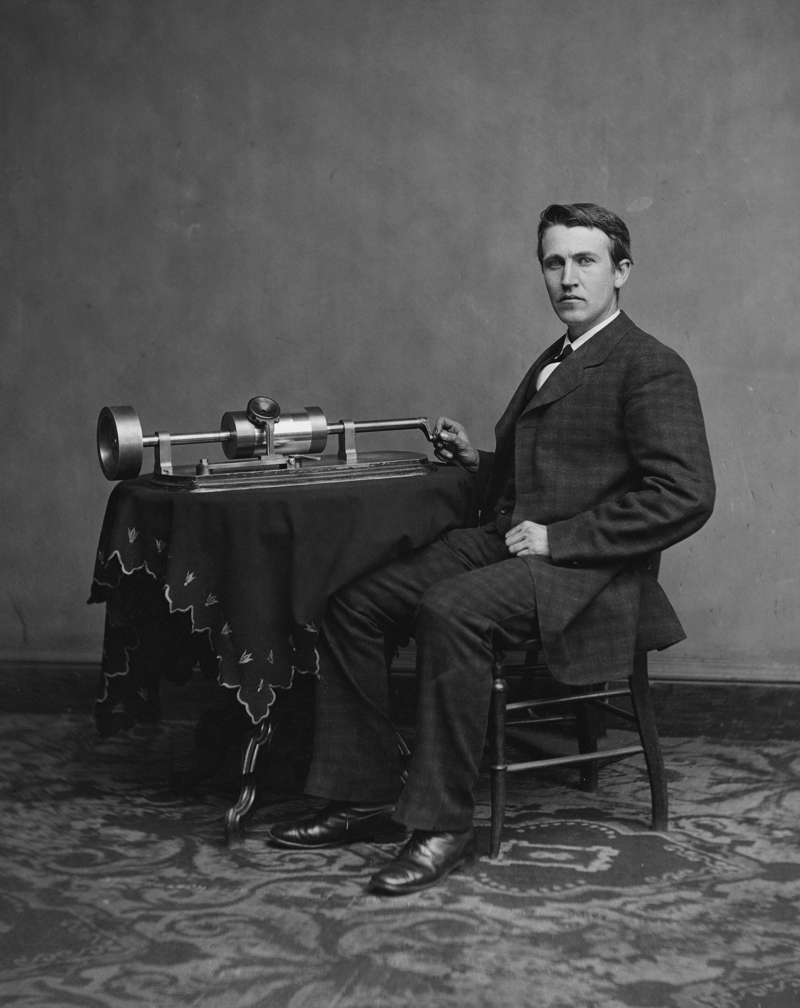
Thomas Edison with his second phonograph photographed by Matthew Brady, April 1878.
http://en.academic.ru/pictures/enwiki/69/Edison_and_phonograph_edit1.jpg

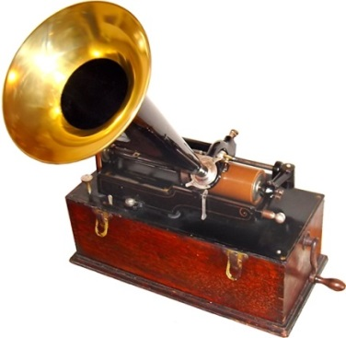
Edison cylinder phonograph ca.1899
http://en.academic.ru/pictures/enwiki/69/EdisonPhonograph.jpg

In his first public display of incandescent lighting, Thomas Alva Edison lit up the streets of Menlo Park, New Jersey on December 31, 1879. The following January, Edison was granted a patent for “an improvement on electric lamps and in the method of manufacturing the same,” and he set out to develop a company that would deliver the electricity to power and light the cities of the world. That same year, Edison founded the Edison Illuminating Company—the first investor-owned electric utility—which later became the General Electric Corporation. Watch the video of Thomas Edison’s Light Bulb at https://www.youtube.com/watch?v=0wkjlSZt0ko.

In 1881, he left Menlo Park to establish facilities in several cities where electrical systems were being installed. In 1882, the Pearl Street generating station provided 110 volts of electrical power to 59 customers in lower Manhattan. In 1887, Edison built an industrial research laboratory in West Orange, New Jersey, which served as the primary research laboratory for the Edison lighting companies. He spent most of his time there, supervising the development of lighting technology and power systems. He also perfected the phonograph, and developed the motion picture camera and the alkaline storage battery.

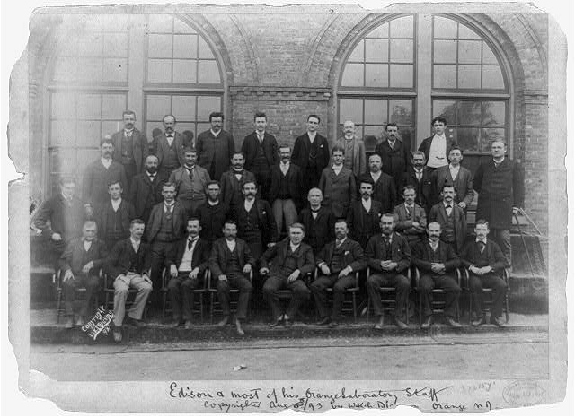
Edison and most of his Lab Staff in West Orange, NJ, 1893, LC-USZ62-98068

Over the next few decades, Edison found his role as inventor transitioning to one as industrialist and business manager. He eventually became embroiled in a longstanding rivalry with Nikola Tesla, an engineering visionary with academic training who worked with Edison's company for a time, parting ways in 1885. The two would publicly clash about the use of direct current electricity, which Edison favored, vs. alternating currents, which Tesla championed. The latter inventor entered into a partnership with George Westinghouse, an Edison competitor as well, and thus a major business feud over electrical power came into being.

But more inventions were in store for Edison: the motion picture. In 1893, the world's first film production studio, the Black Maria, was completed on the grounds of Edison's laboratories at West Orange, New Jersey, for the purpose of making film strips for the Kinetoscope. It got its name because it was large and black and looked like the police wagons of the day, which were called black marias. On January 7, 1894, the experimental kinetoscope film of Thomas Edison’s employee Fred Ott sneezing was filmed at the Edison Laboratories in West Orange. It was the first motion picture copyrighted in the United States. The kinetoscope enabled one person at a time to view moving pictures. In 1895, the French Lumiere brothers invented was a portable motion-picture camera, film processing unit and projector called the Cinematographe, three functions covered in one invention that projected moving, photographic, pictures to a paying audience of more than one person. Later in 1896, Edison showed his improved Vitascope projector and it was the first commercially, successful, projector in the U.S. On April 23, 1896, Edison became the first person to project a motion picture, holding the world's first motion picture screening at Koster & Bial's Music Hall in New York City. On December 1, 1903 “The Great Train Robbery,” the first “western” film, produced by Edison Laboratories and filmed at various locations in New Jersey, was released to the public. Edison produced 200-300 films at the Black Maria.

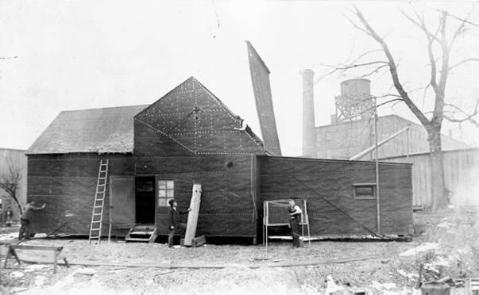
Edison’s Black Maria film production studio on the grounds of Edison’s Lab in West Orange, NJ,1893
http://www.americaslibrary.gov/jb/gilded/jb_gilded_kinetscp_2_e.html
So began the film industry…in New Jersey. By 1914, the early film series, “The Perils of Pauline,” was filmed largely in Fort Lee, NJ. It brought us the term “cliffhanger.” The series premiered At Loew’s Broadway Theater in New York City. By 1918 the film industry had moved to warmer climates in California. Watch the video about the birth of the film industry in Ft. lee, NJ at https://www.youtube.com/watch?v=NPrSt-2o1rw&feature=youtu.be.
And the automobile battery. As the automobile industry began to grow, Edison worked on developing a suitable storage battery that could power an electric car. Though the gasoline-powered engine eventually prevailed, Edison designed a battery for the self-starter on the Model T for friend and admirer Henry Ford in 1912. The system was used extensively in the auto industry for decades.
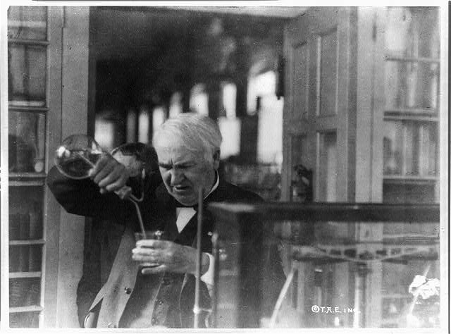
Edison experimenting in his lab, 1920
LC-USZ62-98832

Edison earned 1,093 United States patents, a record number for one person that still stands. He also earned at least several hundred foreign patents from Great Britain, France, Germany and other countries. Most foreign patents were similar to the American ones. Thomas Edison died of complications of diabetes on October 18, 1931, in his home, "Glenmont," in West Orange, New Jersey. He was 84 years old.

Jigsaw Activity: Divide students into six groups. Prepare cards with selections from Edison’s biography (early life, early inventions, Menlo Park lightbulb, phonograph, motion pictures, automobile battery and share one card with each group. Have students jigsaw and explain the early life or inventions of Thomas Edison to the other groups. Have students use Handout 3 to organize and summarize Edison’s life and inventions.

The scientific method: Scientific method is a body of techniques for investigating phenomena, acquiring new knowledge, or correcting and integrating previous knowledge. To be termed scientific, a method of inquiry is commonly based on empirical or measurable evidence subject to specific principles of reasoning. The Oxford English Dictionary defines the scientific method as "a method or procedure that has characterized natural science since the 17th century, consisting in systematic observation, measurement, and experiment, and the formulation, testing, and modification of hypotheses."

Critical thinking activity: Ask students to consider and respond to the following questions (Handout 4) about Edison and his inventions:
- Why did Edison choose to open his lab in NJ?
- How did people react to his inventions?
- How did Edison expect his inventions to be used?
- Did Edison follow the scientific method in developing his inventions?
- Why is Edison considered a pioneer of the research and development process that exists today?
- Does Edison fit the definition of an “entrepreneur”?

Activity: Edison on Trial. Some people believe that historians give too much credit to Edison and not enough is given to his assistants for these inventions. Your job is to sit as a member of a jury that must decide whether or not Edison deserves all of the credit he is given. Since this is a civil case rather than a criminal case, the burden of proof necessary for a guilty verdict is only more likely than not. (over 50%)
- You will be presented with a case for the prosecution that charges that, "Thomas Alva Edison primarily succeeded not because of his own inventive ability, but as a result of the ingenuity and efforts of the many inventors and machinists that worked for him."
- The defense will argue that although Edison did have teams of assistants and machinists, he succeed as a result of his own ideas, intellectual ability, leadership and hard work.
- The court case will rely heavily on statements from Edison and those who knew and worked with him. Any statements in quotes are directly from the witnesses and those that are not in quotes were developed for the purposes of this case based on the opinions and ideas of the witnesses.
For documents and instructions, Go to the NJ Digital Highway at http://www.njdigitalhighway.org/enj/lessons/thomas_edison/?part=edison_on_trial
- Food and New Jersey
Although many scoff at the idea of New Jersey as the “Garden State”, New Jersey is home to more than 9,071 farms covering 715,057 acres of farmland. The state is among the leaders in many forms of agricultural production. For example, New Jersey ranks 5th in blueberry production, 3rd in cranberry production, 3rd in spinach, 3rd in bell peppers, 4th in peach production. It was the location of several important improvements in foods that we eat every day.

Iconic Campbell’s Soup can

Condensed soup. Doctor John T. Dorrance, a chemist with the Campbell Soup Company, in Camden, NJ, invented condensed soup in 1897. Canned soup can be condensed, in which case it is prepared by adding water (or sometimes milk), or it can be "ready-to-eat," meaning that no additional liquid is needed before eating. Condensing soup allows soup to be packaged into a smaller can and sold at a lower price than other canned soups. The soup is usually doubled in volume by adding a "can full" of water or milk (about 10 ounces). Campbell's products are sold in 120 countries around the world. For a video about the Campbell Soup Company go to https://www.youtube.com/watch?list=PLU0OVRbhFK0rDPCDQI42aPb_5MpGikfNG&v=TBpd2zCxEmE.

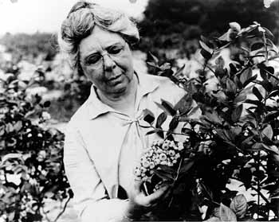
Elizabeth White
http://www.state.nj.us/hangout_nj/200303_womens_history_p6.html
Blueberries. The birthplace of the cultivated blueberry is Whitesbog. Today, blueberries are considered a super-food, rich in vitamins and antioxidants, and grown around the world; North Carolina, Michigan, Georgia, and New Jersey are the top U.S. producers. Americans consume, on average, five cups of blueberries per year . But until the early twentieth century, most farmers thought that wild blueberries could not be cultivated successfully. Elizabeth Coleman White (1871-1954) grew up on her father's cranberry farm in Whitesbog, an agricultural community in the Pine Barrens in Pemberton Township, New Jersey. Whitesbog was the largest cranberry farm in the state and its founder (her father) was a nationally recognized leader in the cranberry industry. At the time, people did not believe that blueberries could be domesticated. In 1911, Elizabeth White became interested in blueberry propagation and, using her father's farm, she collaborated with Dr. Frederick Coville, a U.S. Department of Agriculture botanist, to identify wild blueberry plants with the most desirable properties, crossbreed the bushes and create vibrant new blueberry varieties based on wild varieties. By 1916, they had developed a blueberry plants that could be grown and sold commercially. In 1927, she helped to start the New Jersey Cooperative Blueberry Association. Thanks to Elizabeth White, blueberries are now produced in 38 states, with Michigan producing the most but New Jersey not far behind! For additional information on Elizabeth White, see http://officialnj350.com/elizabeth-white-and-the-blueberry-business-teaching-resource-target-age-middle-school/.

Rutgers tomato
http://www.cherrygal.com/tomatodetrutgersheirloomseeds2014-p-9053.html

The Rutgers tomato was introduced in 1934 by Rutgers breeder Lyman Schermerhorn as an ideal locally well-adapted and improved "General Use" tomato for processing (canning and juicing) as well as fresh market. The Rutgers tomato was developed and released in the period between World War I and World War II, during expansion of canning and truck farming, when 36,000+ acres of tomatoes were grown in the Garden State. The Rutgers tomato was a genuine horticultural improvement over non-certified saved seeds, as well as over commercial varieties, with improved attributes, including: Pleasing flavor and taste of the juice; more uniform sparkling red internal color ripening from center of the tomato outward; smooth skin; freedom from fruit cracking; 'second early' maturity; handsome flattened globe shape; vigorous healthy foliage to ripen more fruit and reduce sunscald; firm thick fleshy fruit walls for its time, though considered extremely soft by today's definition of tomato firmness; uniformity true to type in the field.

Activity: Let me count the ways. How often do you eat a tomato or tomato product (sauce, stewed, sun-dried)? How about a blueberry or blueberry product (yogurt, cake of muffins, etc.)? How about something from a can? What can you conclude about the impact of agricultural improvements from New Jersey based on your calculations?

Consider the method for identifying the best way to cultivate blueberries or tomatoes for market. How are these methods the same as those for other “inventions”? (In both cases, the scientific method of investigating what worked and what did not was followed.)

- Selman Waksman and the development of antibiotics

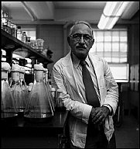
Dr. Selman Waksman in his lab, 1953
From http://www.magnumphotos.com/Catalogue/Erich-Hartmann/1953/USA-Dr-Selman-WAKSMAN-(US)-NN13147.html

Born in Russia (near Kiev) in 1888, Selman Waksman entered Rutgers University as an undergraduate in 1911 and graduate with a Bachelor of Science degree in Agriculture in 1915. He completed his Master's Degree also at Rutgers while working as a research assistant in soil bacteriology at the New Jersey Experimental Agriculture Station. After working in California on his Ph. D in Microbiology he was invited back to Rutgers, where he worked his way up from Associate Professor to head of the Microbiology Department when it was organized in 1940.

In 1928, Scottish bacteriologist Alexander Fleming made a chance discovery from an already discarded, contaminated Petri dish. The mold that had contaminated the experiment turned out to contain a powerful antibiotic, penicillin. However, it wasn’t until 1940 that two scientists at Oxford University, Australian Howard Florey and German refugee Ernst Chain, developed a chemical technique for producing a penicillin that kept its antibacterial power for longer than a few days and was safe to use. Mass production started immediately since the new drug was needed to save lives that otherwise would have been lost due to bacterial infections in even minor wounds.

At the turn of the 20th century, tuberculosis was an urgent health problem. It was contagious and usually fatal. No immunization or effective treatment was available. Individuals with tuberculosis were isolated in facilities. In 1882 the Prussian physician Robert Koch had identified the cause of tuberculosis to be a specific bacteria or bacillus. He developed a protein from the bacteria with the hope that it would prove to provide effective immunization, but it did not. Since 1915, Dr. Waksman had been analyzing soil. In 1939, i.e. one year before the rediscovery of penicillin by Florey and Chain, Dr. Waksman started an extensive study aimed at determining the nature of the substance by which the various soil microbes destroyed each other. In 1940 Dr. Waksman and his colleagues at Rutgers University had succeeded in isolating the first antibiotic, which was called “actinomycin” but it was very toxic. In 1942 another antibiotic was detected and studied, called “streptothricin”. This had a high degree of activity against many bacteria and also against the tubercle bacillus but was also too toxic. During the streptothricin studies Dr. Waksman and his colleagues, Albert Schatz, Elizabeth Bugie, developed a series of test-methods, which helped to isolate the antibiotic, streptomycin, in 1943. Streptomycin was the first effective cure for tuberculosis and dramatically reduced the number of cases, although the hope of total eradication has been thwarted by the development of drug-resistant strains.

In 1949, an Institute of Microbiology was established at Rutgers University with Dr. Waksman as its first Director. Today this institute bears his name. In 1952, he was awarded the Nobel Prize for Physiology/Medicine for his work on antibiotics (including streptomycin) and their effect on tuberculosis. Located on Busch Campus of Rutgers, The State University of New Jersey, the Waksman Institute of Microbiology is an interdisciplinary research institute devoted to excellence in basic research including developmental biology, cell biology, biochemistry, structural biology, genetics, and genomics but now employs molecular tools to streamline and accelerate laboratory processes. Watch the video at https://youtu.be/_PB-OVGVWGg. Although he officially retired from Rutgers in 1958, Dr. Waksman still maintained an office and conducted research from time to time. A research facility on the campus on the Technion Institute of Technology in Haifa, Israel, was established in 1962 with Dr. Waksman as its director. Dr. Waksman died in 1973.

Activity: The role of the legal system in the creation of, protection of, and profit from intellectual property such as new antibiotics. The pharmaceutical/chemical manufacturer Merck and Co. was interested in manufacturing and marketing these new antibiotics. Dr. Waksman could have used his discoveries to make himself rich, but chose instead to divert most of the profits of his work to the Institute. His influence at Merck led Merck to give up its exclusive license on the manufacture of streptomycin so that it could be licensed to other companies in order to rapidly distribute it for the treatment of tuberculosis. In spite of his philanthropic approach, Albert Schatz, one of Dr. Waksman’s research assistants, sued him for a share of the profits. For directions and documents to use regarding this law suit to understand the role of the legal system in protecting inventions and intellectual property, go to the NJ Digital Highway at
http://www.njdigitalhighway.org/enj/lessons/selman_waksman/?part=patents_and_profits.

- Bell Labs and the start of the electronic and internet revolution
Watch the video about Bell labs at https://www.youtube.com/watch?v=yJwkOzJ7bjA. Bell Labs has its roots in the consolidation of several engineering departments within the American Telephone & Telegraph (AT&T) company and the Western Electric company, the manufacturing organization for the Bell System. These departments had been tasked with overcoming the day-to-day engineering challenges of building a national communications network. But as large parts of that network were deployed and the emerging telephone business took hold in the 1920s, attention increasingly turned to exploring fundamental areas of science likely to shape the future of the industry.

As a result, about 4,000 of these scientists and engineers were assigned to a newly created Bell Telephone Laboratories, Inc. in 1925, and were to be fully dedicated to such research. Go to http://www.bell-labs.com/claude-shannon/ for background on early work at Bell Labs “Math Department”.

Bell Labs headquarters was in Murray Hill, NJ. In 1934, AT&T’s Development and Research Department, which had been devoted to bridging the gap between laboratory research and the operations of communication systems, was integrated into Bell Laboratories. Growth continued as engineers from development departments were also folded into Bell Laboratories. In 1947, the transistor was developed a Bell Labs, the start of the 20th century communications revolutions that has resulted in cell phones and computers. Scientists from Bell Labs developed a wide range of revolutionary technologies, including the laser, information theory, the UNIX operating system, the C programming language and the C++ programming language. Eight Nobel Prizes have been awarded for work completed at Bell labs.

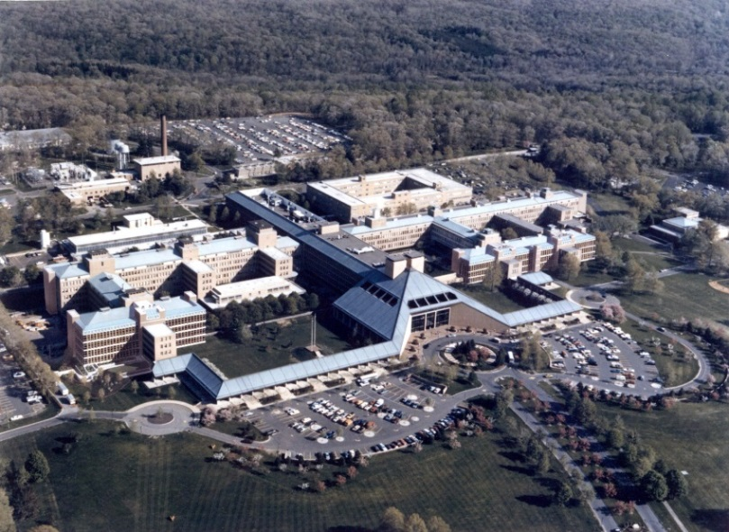
Bell Labs, Murray Hill, NJ at https://beta.waevio.com/memoir/bell_labs#connect

As a consequence of a divestiture agreement with the U.S. Government in 1984, AT&T Corporation divested itself of its local exchange companies and the Bell System as it was known ceased to exist. As part of the divestiture agreement, AT&T Technologies assumed the business of Western Electric and Bell Laboratories. Concurrently, several thousand Bell Laboratories employees were split off to form Bellcore, the organization established to provide research and technical functions for the newly independent local exchange carriers. In 1996, AT&T spun off most of Bell Laboratories and its equipment manufacturing business into Lucent Technologies, Inc. (now Alcatel-Lucent). Bell Laboratories is a research and scientific development company that now belongs to Nokia. Its headquarters are located in Murray Hill, New Jersey, in addition to other laboratories around the rest of the United States and in other countries.
Activity: Questions to consider (Handout 5):

- How does Bell Labs differ from Edison’s Invention Lab? How it is similar?
- Not all inventors are entrepreneurs. Can the teams working at Bell Labs be considered entrepreneurs if the risk is taken by the company?
- How much can one person’s innovation reshape a region? How important is collaboration in bringing such innovations to fruition?
- What current companies do you think of as “entrepreneurial” today? Why do they fit the definition?

Assessment

The Invention Process. Have students work in small groups to brainstorm and come up with possible inventions that would make your lives easier, safer, or more enjoyable and then go through Edison’s process for developing the invention. For directions and details, go to: http://www.njdigitalhighway.org/enj/lessons/thomas_edison/?part=invention_process

Extension

- Visit Paterson Great Falls, a National Historical Park. For more information go to www.nps.gov/pagr
- Visit Speedwell Historic Village, outside of Morristown with seven preserved buildings, including the Vail House, the Wheel House, the Granary, the Carriage House and Ford Cottage . and 19th century Georgian mansion and an early 19th century House with changing exhibits. For information go to http://37.60.235.13/~morrispa/index.php/parks/historic-speedwell or call 973-285-6550.
- Visit Thomas Edison’s home, Glenmont, and his Lab Complex, in West Orange, NJ are both part of the National Park Service and open for visitors. For additional information go to http://www.nps.gov/edis/planyourvisit/hours.htm
- Visit the Thomas Edison Center at Menlo Park & Edison Memorial Tower, at 37 Christie St. and Route 27 in Edison, NJ 08820, marks the spot where the light bulb was perfected. There is an exhibit of Edison memorabilia. Open Thurs. - Sat., 10 am - 4 pm. For more information go to http://www.visitnj.org/nj-historic-sites-memorials/thomas-edison-center-menlo-park-edison-memorial-tower#sthash.0b5dbcxm.dpuf
- Visit Historic Whitesbog Village: On both the National and State Registers of Historic Sites, Whitesbog offers living history tours, a quarterly lecture series, seasonal programs, and festivals. http://www.whitesbog.org

Handout 1: John Stevens and James Watt

 | James Watt | John Stevens
Birth date and place

Families

Eduational Background
Accomplishments

Legacies

Other information

Handout 2: Gibbons v. Ogden, 22 U.S. 1 (1824)

The facts: A New York state law gave to individuals the exclusive right to operate steamboats on waters within state jurisdiction. Laws like this one were duplicated elsewhere which led to friction as some states would require foreign (out-of-state) boats to pay substantial fees for navigation privileges. In this case Thomas Gibbons -- a steamboat owner who did business between New York and New Jersey under a federal coastal license -- challenged the monopoly license granted by New York to Aaron Ogden. New York courts consistently upheld the state monopoly. On appeal to the U.S. Supreme Court under Art III, Section 2 granting the federal courts jurisdiction over cases arising “between Citizens of different States,” the question was: Did the State of New York exercise authority in a realm reserved exclusively to Congress, namely, the regulation of interstate commerce?

The decision: The unanimous Court ruled for Gibbons, holding that New York’s exclusive grant to Ogden violated the federal licensing act of 1793. The New York law was invalid by virtue of the Supremacy Clause U.S. Constitution, Art. I, Sec. 8, Clause 3, which granted Congress the power “to regulate Commerce with foreign Nations, and among the several States, and with the Indian tribes”.

The reasoning: “The subject to be regulated is commerce, and our Constitution being,… one of enumeration, and not of definition, … it becomes necessary to settle the meaning of the word. …Commerce, undoubtedly, is traffic, but it is something more: it is intercourse. It describes the commercial intercourse between nations, and parts of nations, in all its branches, and is regulated by prescribing rules for carrying on that intercourse.
…. All America understands, and has uniformly understood, the word "commerce" to comprehend navigation. It was so understood, and must have been so understood, when the Constitution was framed. The power over commerce, including navigation, was one of the primary objects for which the people of America adopted their government, and must have been contemplated in forming it. The convention must have used the word in that sense, because all have understood it in that sense, and the attempt to restrict it comes too late.
The word used in the Constitution, then, comprehends, and has been always understood to comprehend, navigation within its meaning, and a power to regulate navigation is as expressly granted as if that term had been added to the word "commerce."
To what commerce does this power extend? The Constitution informs us, to commerce "with foreign nations, and among the several States, and with the Indian tribes."
…The word "among" means intermingled with. A thing which is among others is intermingled with them. Commerce among the States cannot stop at the external boundary line of each State, but may be introduced into the interior.
It is not intended to say that these words comprehend that commerce which is completely internal, which is carried on between man and man in a State, or between different parts of the same State, and which does not extend to or affect other States. Such a power would be inconvenient, and is certainly unnecessary.
Comprehensive as the word "among" is, it may very properly be restricted to that commerce which concerns more States than one. …The genius and character of the whole government seem to be that its action is to be applied to all the external concerns of the nation, and to those internal concerns which affect the States generally, but not to those which are completely within a particular State, which do not affect other States, and with which it is not necessary to interfere for the purpose of executing some of the general powers of the government. The completely internal commerce of a State, then, may be considered as reserved for the State itself.
…We are now arrived at the inquiry -- What is this power?
It is the power to regulate, that is, to prescribe the rule by which commerce is to be governed. This power, like all others vested in Congress, is complete in itself, may be exercised to its utmost extent, and acknowledges no limitations other than are prescribed in the Constitution. …If, as has always been understood, the sovereignty of Congress, though limited to specified objects, is plenary as to those objects, the power over commerce with foreign nations, and among the several States, is vested in Congress as absolutely as it would be in a single government, having in its Constitution the same restrictions on the exercise of the power as are found in the Constitution of the United States.
The power of Congress, then, comprehends navigation, within the limits of every State in the Union, so far as that navigation may be in any manner connected with "commerce with foreign nations, or among the several States, or with the Indian tribes." It may, of consequence, pass the jurisdictional line of New York and act upon the very waters to which the prohibition now under consideration applies.
…the Court will enter upon the inquiry whether the laws of New York, as expounded by the highest tribunal of that State, have, in their application to this case, come into collision with an act of Congress and deprived a citizen of a right to which that act entitles him.
…the framers of our Constitution foresaw this state of things, and provided for it by declaring the supremacy not only of itself, but of the laws made in pursuance of it. The nullity of any act inconsistent with the Constitution is produced by the declaration that the Constitution is the supreme law. The appropriate application of that part of the clause which confers the same supremacy on laws and treaties is to such acts of the State Legislatures as do not transcend their powers, but, though enacted in the execution of acknowledged State powers, interfere with, or are contrary to, the laws of Congress made in pursuance of the Constitution or some treaty made under the authority of the United States. In every such case, the act of Congress or the treaty is supreme, and the law of the State, though enacted in the exercise of powers not controverted, must yield to it.”

Handout 3: Thomas Edison Graphic Organizer
 | Dates | Key facts
Early Life

Teletype

Lightbulb

Phonograph

Motion picture

Automobile battery

Invention factory

Handout 4: Answer the following questions about Edison and his inventions

- Why did Edison choose to open his lab in NJ?

- How did people react to his inventions?

- How did Edison expect his inventions to be used?

- Did Edison follow the scientific method in developing his inventions?

- Why is Edison considered a pioneer of the research and development process that exists today?

- Does Edison fit the definition of an “entrepreneur”?

Handout 5: Bell Labs Questions to consider

- How does Bell Labs differ from Edison’s Invention Lab? How it is similar?

- Not all inventors are entrepreneurs. Can the teams working at Bell Labs be considered entrepreneurs if the risk is taken by the company?

- How much can one person’s innovation reshape a region? How important is collaboration in bringing such innovations to fruition?

- What current companies do you think of as “entrepreneurial” today? Why do they fit the definition?

