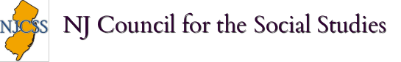
Certificate of Professional Development

Provider: New Jersey Council for the Social Studies
Provider # 820
Title of Activity: Teaching the 3R's: Rights, Reforms, Regions
Date: October 23, 2017
Location: Rutgers University, Princeton, NJ

Number of Professional Development Hours: 5

Educator’s Name: ___________________

